## LAB01 Test-bed setting[STEP 1-5]

|  |  |
| --- | --- |
| Student ID | B2014926 |
| Name | Tran Dang Khoa |
| Email address | [Khoab2014926@student.ctu.edu.](mailto:Khoab2014926@student.ctu.edu)  vn |
| Class | Ct201h |
| Submitting date | 25-08 |

### [STEP 1] Virtual Machine status check

#### Which VM OS type will you use for your exercise?

|  |  |  |  |  |  |
| --- | --- | --- | --- | --- | --- |
|  | Real host | VM OS | | | |
|  | Windows | Ubuntu | Centos | Kali | Windows |
| VMware |  |  |  |  |  |
| VirtualBox | **X** | **X** |  |  |  |

* Mainly we will use Ubuntu

1. **Check your Virtual Machine name** Ubuntu **[$ uname –a]**

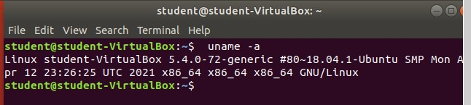

1. **Check your guest OS name** Ubuntu**: GNU/Linux [$ uname –o]**



1. **What kind of linux for Virtual Machine?** Ubuntu **[$ uname –r]**



### [STEP 2] Define the addresses of test-bed table (snap shot)

|  |  |  |
| --- | --- | --- |
| **Role** | **SENDER** | **TARGET** |
| Tester | Victim |
| IP address | Student’s real IP Student’s VM IP  (Kali, Ubuntu, Centos each) | * real system :CTU,CICT U RL, IP * student’s VM IP   (Kali, Ubuntu, Centos each)   * loopback address * neighbor PC IP in class |
| HW | Class terminal | Class terminal |
| NW device | Hub, router, GW |  |
| OS | Real host(window) VM(Kali,Ubuntu,Centos) | Real host(window) VM(Kali,Ubuntu,Centos) |
| SW |  |  |

1. Check host IP[Window] CMD ipconfig/all

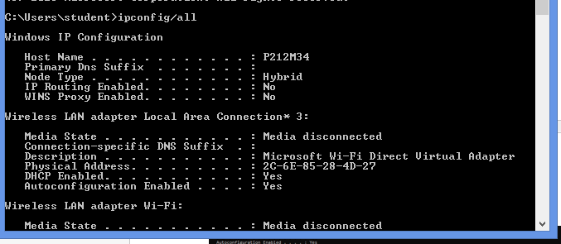

1. Check VM IP [Linux]

$ Sudo apt install net-tools

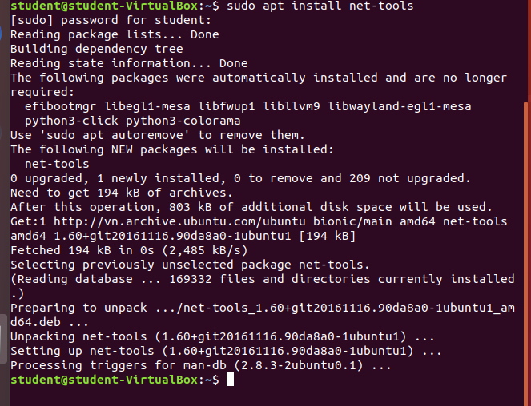

$ ifconfig

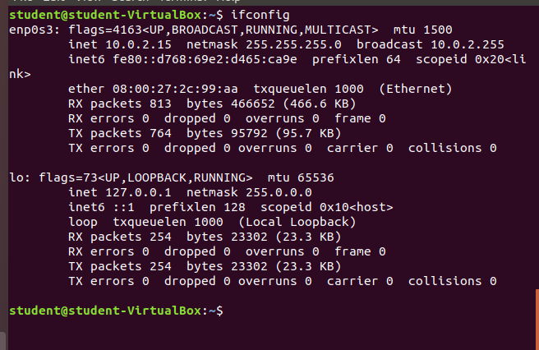

* + Ubuntu
  + Centos
  + Kali

1. Define target IP [Windows:CMD nslookup URL]
   * CTU IP

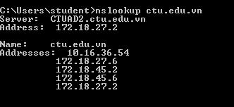

* + CICT IP

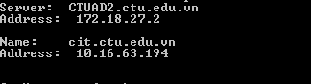

* + loopback address [Windows]

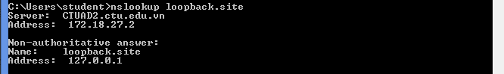

* + neighbor PC IP in class [Windows] => your classmate IP

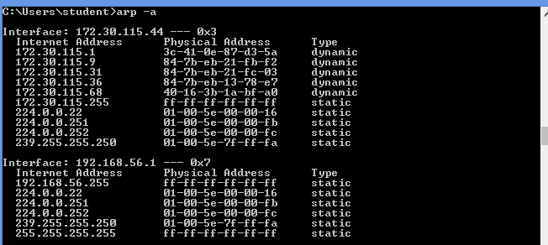

### [STEP3] Check packet exchanging status between sender and target comman d prompt (snap shot)

1. Ping from Host[Windows] to Virtual Machine [Linux] OS

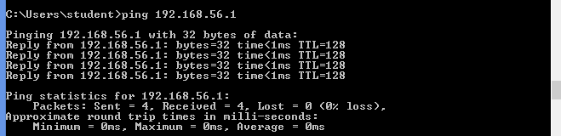

1. Check TTL value with Ping

-TTL Value: 64

1. Ping from Virtual Machine OS [Linux] to Host [Windows]

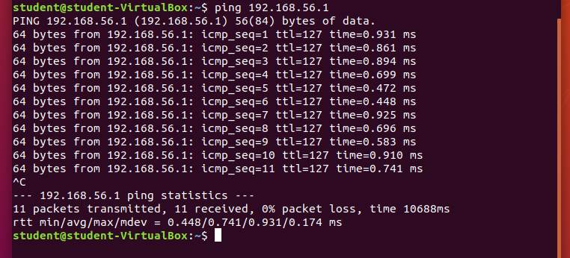

1. Check TTL value with Ping

-TTL Value: 128

1. Ping from Host[Windows] to loopback[Windows] of terminal

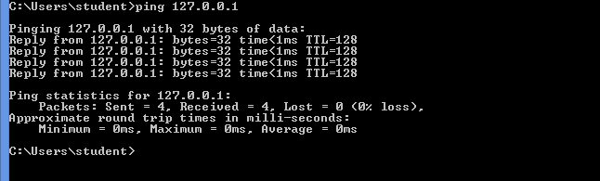

1. Explain the meaning of TTL (time to live) in Ping reply

### [STEP 4] Check routing route status between sender and target (snap shot)

1. Tracert from Host[Windows] to [Linux] and check how many nodes were connected for packet transmission with Tracert?

Windows:CMD tecert

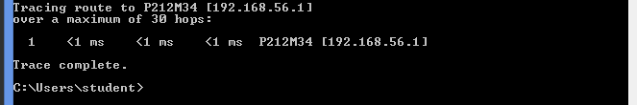

1. Traceroute from Virtual OS [Linux] to Host [Windows] and check how many nodes were connected for packet transmission with Traceroute?

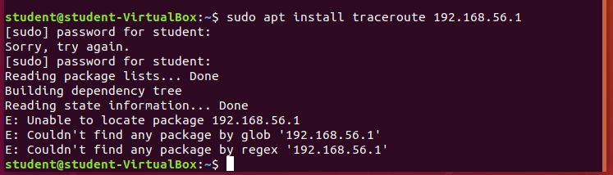

1. Tracert from Host [Windows] to loopback of terminal [Windows:CMD] Windows:CMD tecert to loopback

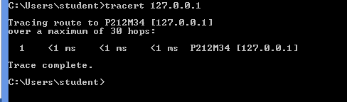

It’s 14 nodes.

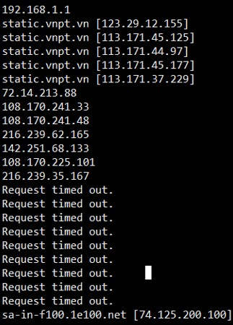

### [STEP 5] Advanced Ping test [Linux]:

1. Send 5 packets to facebook.com, from Windows ping -c 5 facebook.com.

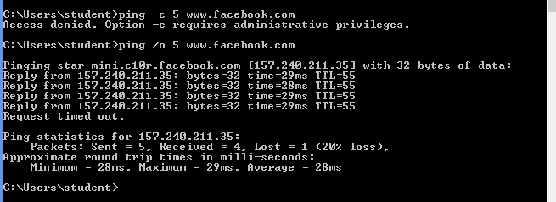

1. ping Facebook for 10 seconds from Ubuntu and then display the results ping -w 10 facebook.com.

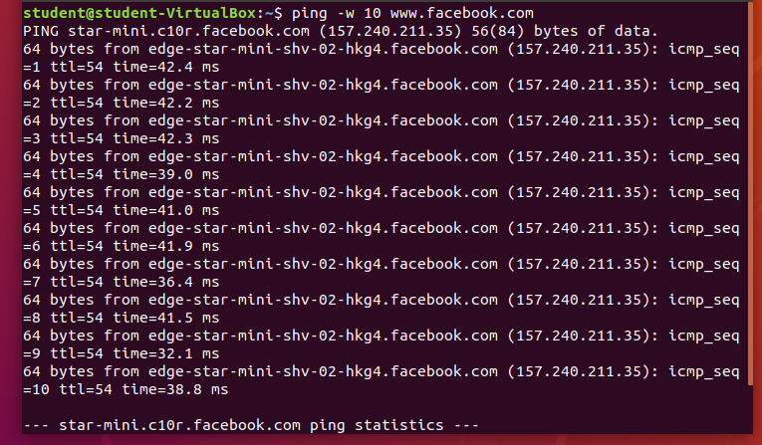

[Change the interval between packets]

1. To increase the wait to 3 seconds between packets in your ping to Facebook, you'd use fr om Ubuntu

ping -i 3 facebook.com.

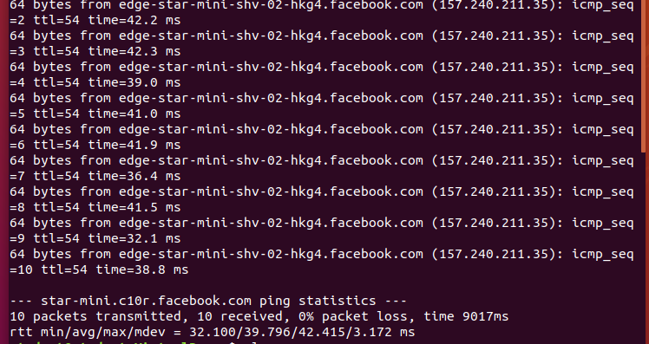

1. To decrease the wait to half of one second, from Ubuntu

ping -i 0.5 facebook.com.

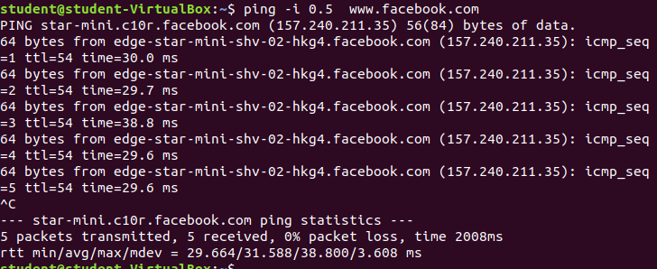

[Change the size of your packets].

1. By default, ping packets are 56 bytes, To send 1000 bytes instead of the default, you'd us e

ping -s 1000 facebook.com. from Ubuntu

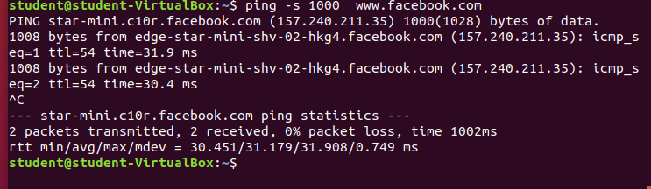

https://www.wikihow.com/Ping-in-Linux#/Image:Ping-in-Linux-Step-2-Version-3.jpg

<https://monovm.com/post/33/how-to-ping-in-centos>

<https://m.wikihow.com/Ping-in-Linux>

## LAB02 step01-Window Nmap

|  |  |
| --- | --- |
|  |  |
| Name | Tran Dang Khoa |
| Email address | [Khoab2014926@student.cu.edu.vn](mailto:Khoab2014926@student.cu.edu.vn) |
| OS | Windows |
| Web bro | Chrome |

#### Its illegal to scan outside network

1. Install Windows Nmap



1. Confirm Windows Nmap installation
2. CMD nmap

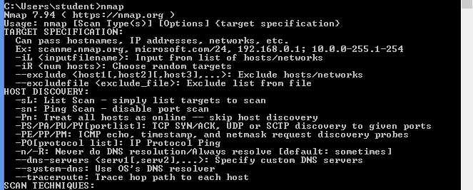

1. CMD nmap-h

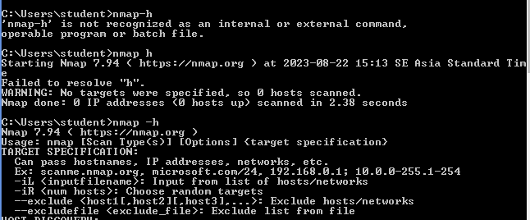

#### Design [Nmap](https://nmap.en.lo4d.com/windows) scanning pen-test scenario under Windows

|  |  |  |
| --- | --- | --- |
|  | scanner | target |
| OS | Windows | Windows, Linux |
| IP address | Test - bed host IP | * Localhost |
|  |  | * CTU IP |
| scanning program | Windows [**Nmap**](https://nmap.en.lo4d.com/windows) | * CICT IP |
| scanning types | -sT: -sS: -sP:  -sU: -sF -P-PB  -O -PS | * Neighboring PC IP * VM IP(Ubuntu, Centos) |

1. Execute Windows Nmap based on upper 3.scenario (screenshot and explain the scanning)
2. nmap –sT CTU, explain the meaning of nmap –sT

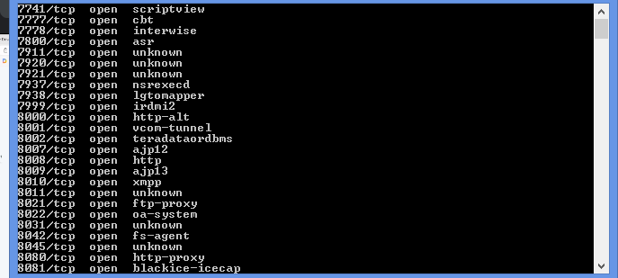

1. nmap –sS CTU, explain the meaning of nmap –sSl

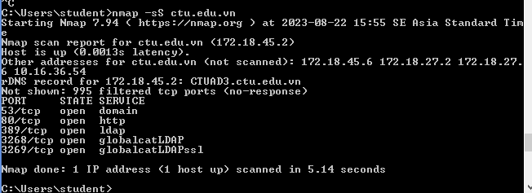

1. nmap – sP CICT, explain the meaning of nmap –sP

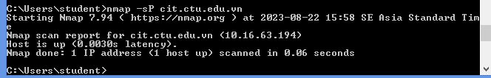

1. nmap -sU CICT, explain the meaning of nmap –sU

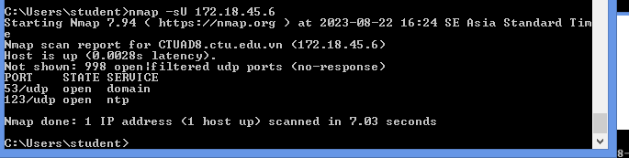

1. nmap -sF VM IP, explain the meaning of nmap –sF

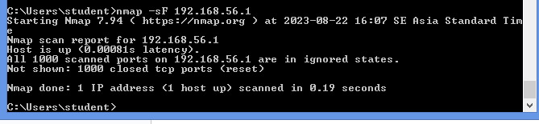

1. nmap -PB VM IP, explain the meaning of nmap –PB

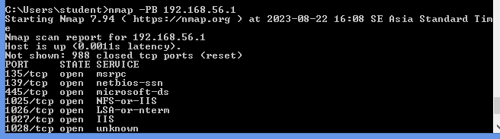

1. nmap -O VM IP IP, explain the meaning of nmap –O

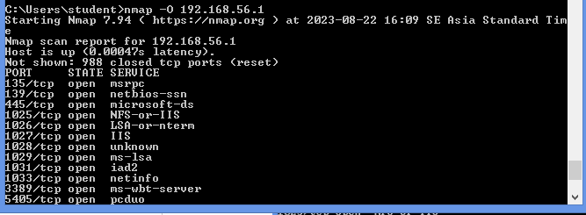

1. nmap -PS VM IP, explain the meaning of nmap –PS

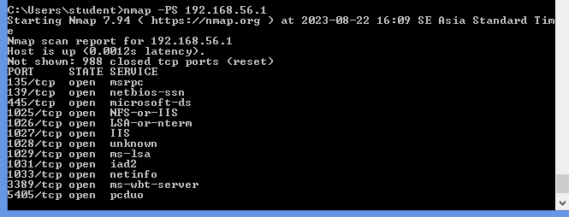

<https://nmap.org/download.html> <http://www.insecure.org/nmap/>

## LAB03 Zenmap

|  |  |
| --- | --- |
| Class | CT201H |
| Student ID | B2014926 |
| Name | Tran Dang Khoa |
| Email address | B2014926 |
| Class |  |
| Browser | Safari, Chrome, IE, Firefox |

#### Design Zenmap scanning pen-test scenario under Windows

|  |  |  |
| --- | --- | --- |
|  | scanner | target |
| OS | Windows Ubuntu | Windows, Linux |
| IP address | Test - bed host IP | Localhost CTU IP CICT IP  Neighboring PC IP  VM IP(Ubuntu, Centos) |
| scanning program | Zenmap Windows Zenmap Ubuntu |
| scanning types | scan in profile field scan in command field scan in menu bar |

**If you find error message, capture it on LAB report and explain**

* 1. Install Zenmap on Window or on Ubuntu (select one)

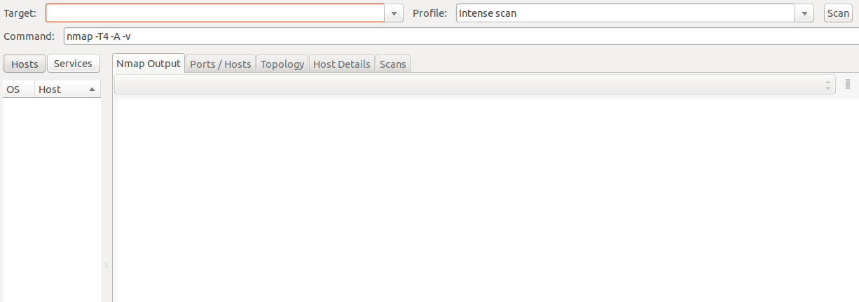

#### scan in profile field and explain the scan command

1. Intense Scan Command: nmap -T4 -A -v *<target>*

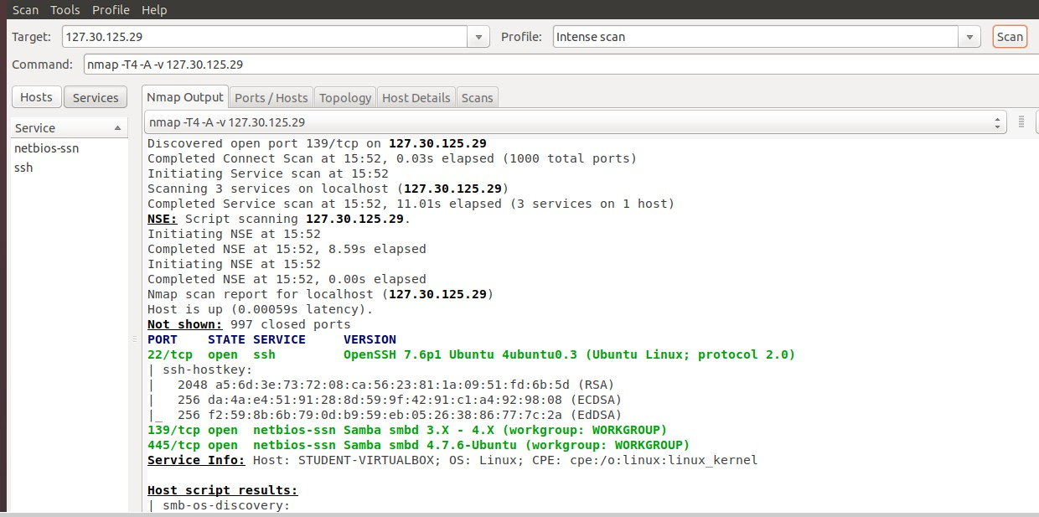

1. Intense Scan, all TCP Ports Command: nmap -p 1-65535 -T4 -A -v <target>

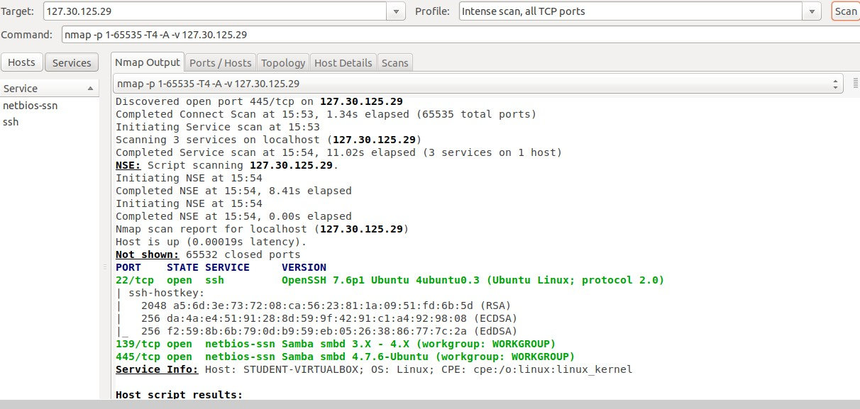

* + Nmap -p 1-65535 -T4 -A -v is an Namp command that performs an extensive and aggressive scan of all possible ports on the target systems, while also attempting to identify the operating system and service versions. The use of ‘-v’ provides detailed output, and ‘- T4’ sets the timing template for the scan to be faster but less stealthy. This command is useful when you want to thoroughly inspect a target system’s services and are willing to accpect the increased scan time and potentially less stealthy approach.

1. Intense Scan, no ping Command: nmap -T4 -A -v -Pn <target>

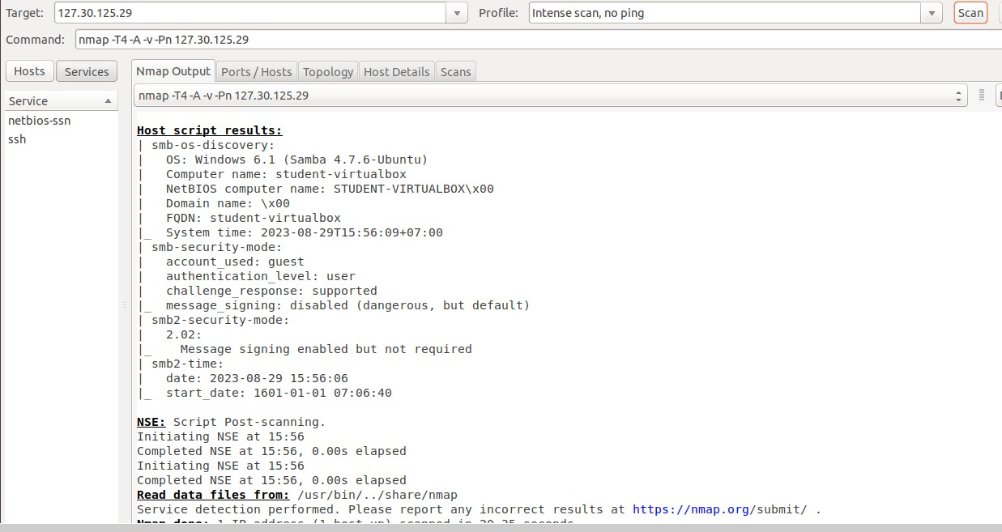

* + namp -T4 -A -v -Pn’ is an namp command that performs an aggressive and thorough scan of a target host or network. It attempts to identify the operating system and service version, provides detailed output, and skips the host discovery phase to save time when you are sure about the target’s online status. This command is useful for in-depth network reconnaissance when speed is a priority and stealthiness is not a major concern.

#### Scan in command field and explain the scan command

1. Ping Scan Command: nmap -sn <target>

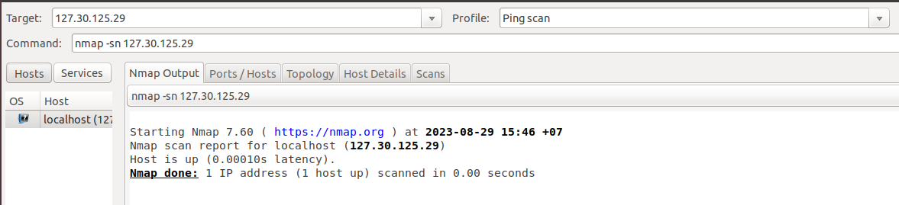

* + It simply sends ping requests to the target host to check if the target host is alive or not. As the example below, I use a ping scan to check if the target host is alive or not and, as the result, it seems alive.

1. Quick Scan Command: nmap -T4 -F <target>

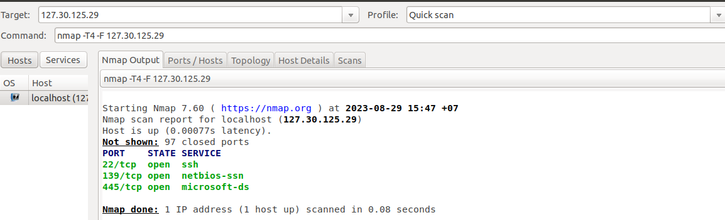

* + Quick scan simply scan faster than the intense scan and limit the number of ports scanned to only 100 most common TCP ports.

1. Quick Trace Route Command: nmap -sn --traceroute <target>

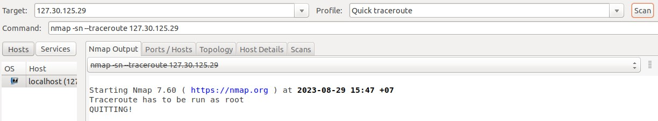

* + This scan means traceroute and ping all hosts defined in the target. 7 Regular Scan Command: nmap *<127.30.125.29>*

1. Regular Scan Command: nmap <target>

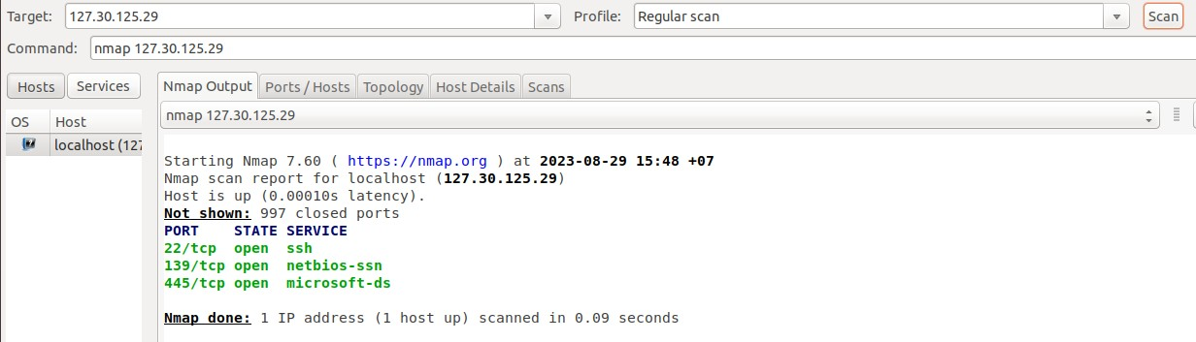

* + The regular scan is the default scanning, TCP scanning, it simply scans and shows open services or ports on the target host, usually scans the 1000 most common ports. The scan below scanned 998 filtered ports and only two are open.

#### Scan in menu bar and explain scan command

1. Press Hosts button & explain

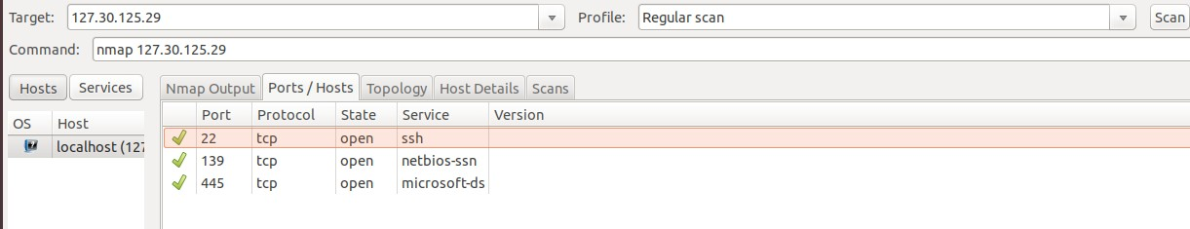

* + It simply displays all hosts that were scanned. Each host is labeled with its hostname or domain name, IP address and has an icon indicating the OS that was detected for that host. The figure below shows only no specific OS or OS detection not performed on that hosts.

1. Press Services button & explain

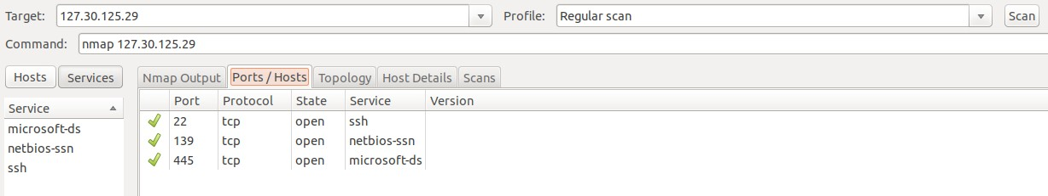

* + It displays all services that were scanned and which ports or hosts use that service. 10 Press Nanmap output button & explain

1. Press Nanmap output button & explain

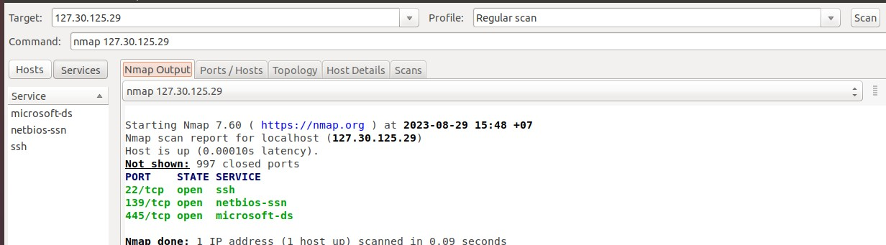

* + It simply shows the results scan of nmap commands.

1. Press Ports / Hosts button & explain

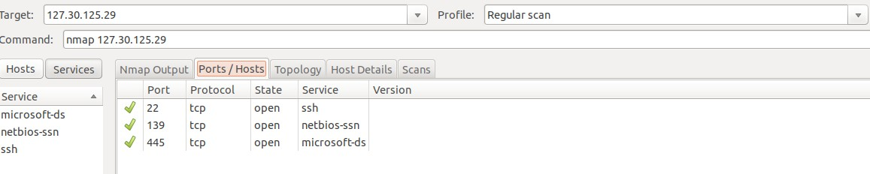

* + The “Ports / Hosts” tab's display differs depending on whether a host or a service is currently selected. When a host is selected, it shows all the interesting ports on that host, along with version information when available. When a service is selected, the “Ports / Hosts” tab shows all the hosts which have that port open or filtered.

1. Press Topology button & explain

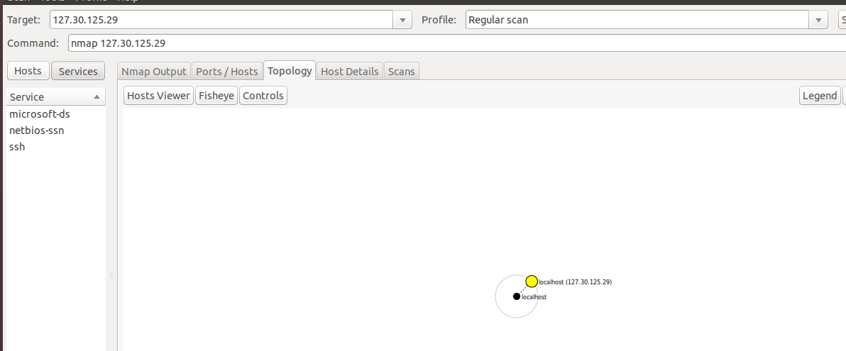

* + The “Topology” tab shows the connections between hosts in a network. It is a visual view of the traceroute. From the figure below, I can see, the black circle is my local host.
  + It has some green circle (because that has fewer than 3 open ports) clustered around localhost and has connected with a dashed black line (seems that with no traceroute information).
  + In the figure, I also see a white circle on the effort to connect to the ctu.edu.vn domain, the white circle represents it is an intermediate host in the network path that was not port scanned.
  + The bigger circle show that has a more open port on the host, the thickness of the blue line in the figure below shows it is a primary traceroute. As we can see in the figure below, they have two yellow squares, which means that hosts with some ports are filtered.

1. Press Host details button & explain

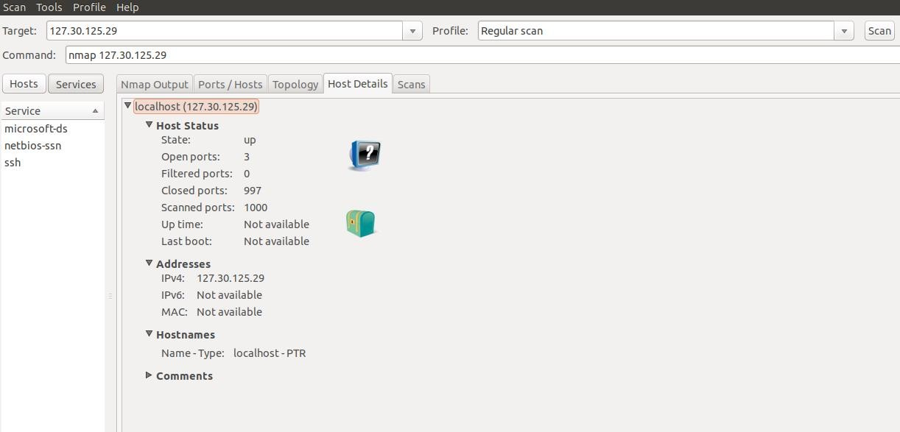

* The “Host Details” tab shows pieces of information of host about Host status, Address.
* Hostnames, Operating System, OS class, Ports used by Host.
* Each host has an icon that provides a very rough “vulnerability” estimate, which is based solely on the number of open ports. From the figure below, I can see that host has 1 open port so the host has the icon below (the icon below will be shown if has 0-2 open ports).

<https://linuxhint.com/zenmap_ubuntu_nmap/>

## LAB04 packet analyzing

페

이 지P AG E

\* M

|  |  |
| --- | --- |
| Class | M02 |
| Student ID | B2014926 |
| Name | Tran Dang Khoa |
| Email address | [Khoab2014926@student.ctu.edu.vn](mailto:Khoab2014926@student.ctu.edu.vn) |
| Class | M02 |
| Browser | Safari, Chrome, IE, Firefox |

### Design packet analyzing process under Windows

|  |  |  |
| --- | --- | --- |
|  | scanner | target |
| OS | Windows Ubuntu | Windows, Linux |
| IP address | Test - bed host IP | Localhost CTU IP CICT IP  Neighboring PC IP  VM IP(Ubuntu, Centos) |
| Analyzing program | Wireshark |
| Analyzing types | Filter ARP packet Filter TCP packet |

1. **Survey following menu and explain**
   1. 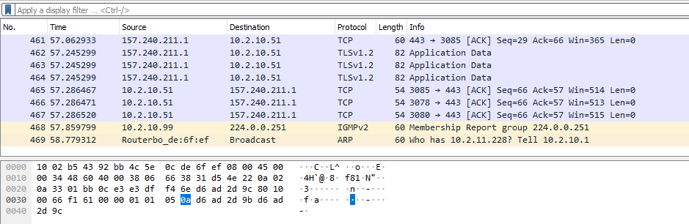View – packet details

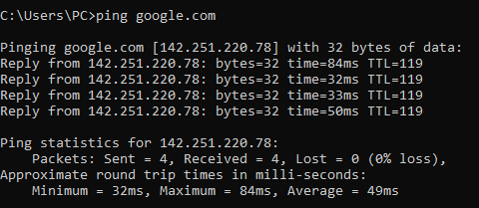

페

이 지P AG E

\* M

Explan:

* 1. Statistics - Protocol Hierarchy

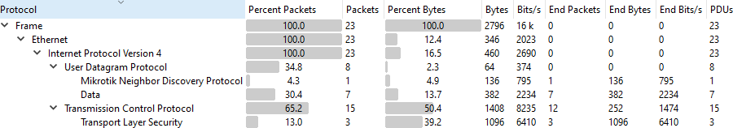

Explan:

* 1. 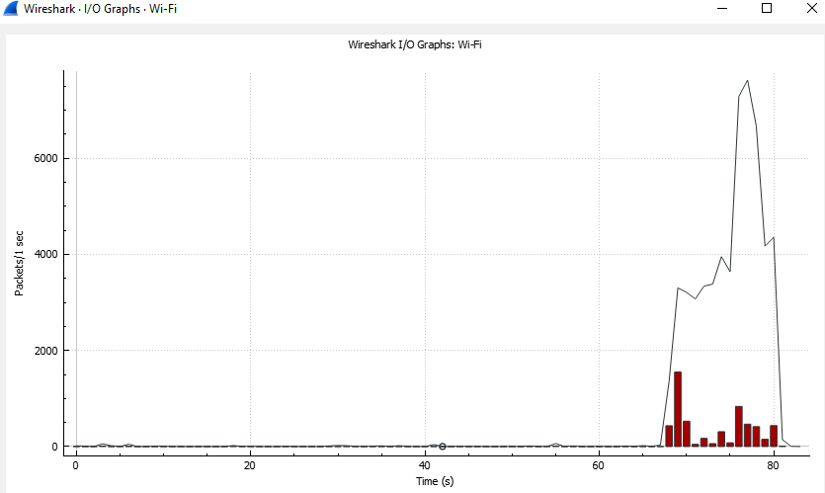Statistics - I/O graph -100ms- time of day

Explan:

페

이 지P AG E

\* M

* 1. Statistics – Flow Graph- Tcp flows[three way hand shake]

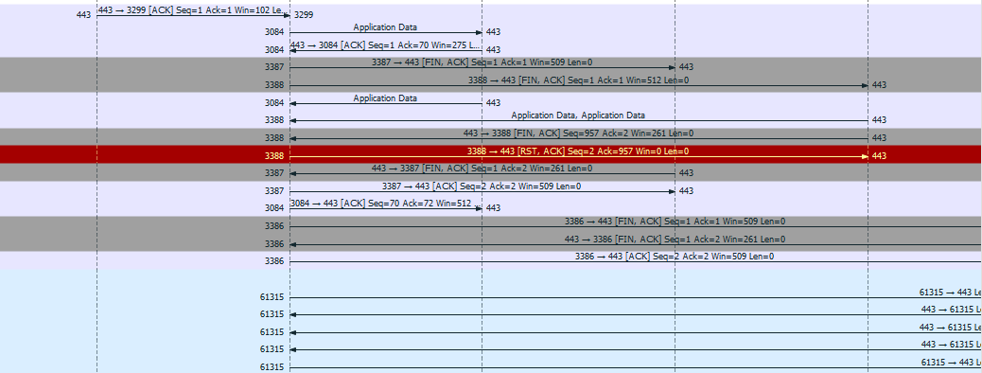

Explan:

### Filter ARP packet

* 1. Filter ARP request packet : arp.opcode == 1

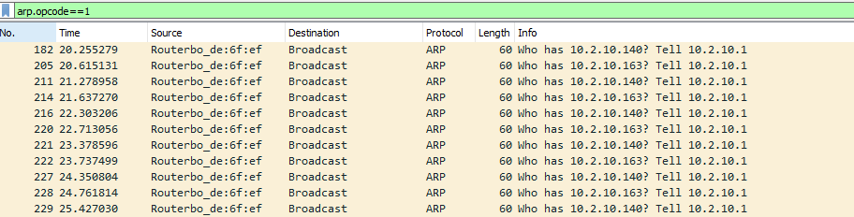

* 1. Analyze ARP request packet

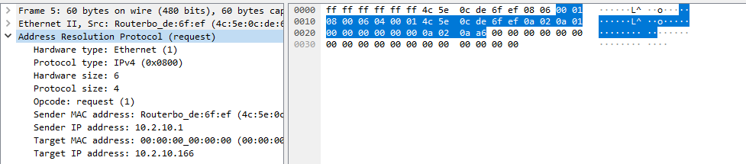

* 1. Filter ARP reply packet : arp.opcode == 2

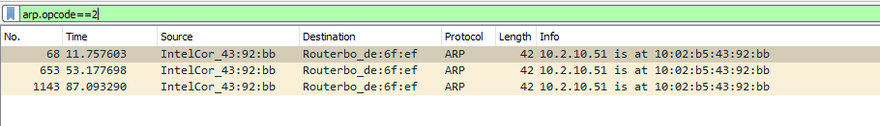

페

이 지P AG E

\* M

* 1. Analyze ARP reply packet

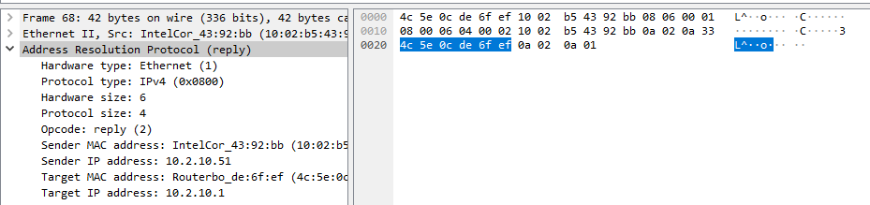

### Filter SYN packet

* 1. Filter SYN packet : tcp.flags.syn ==1

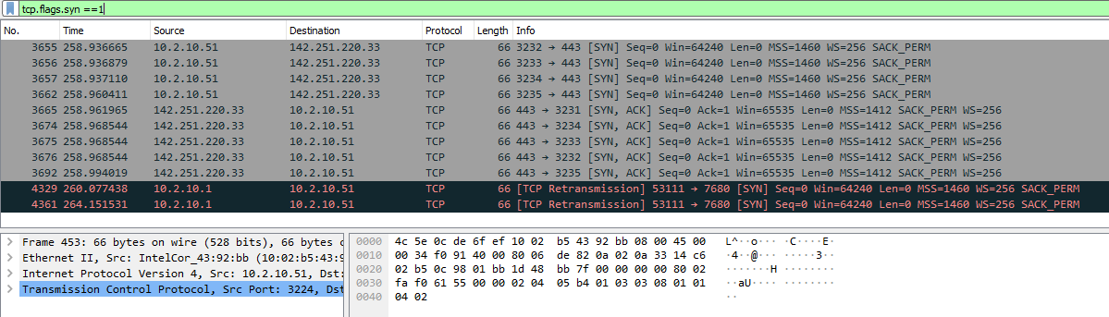

* 1. Explain seq, ack, leng of SYN packet?

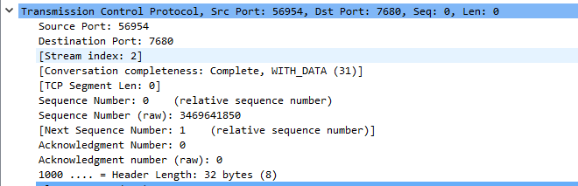

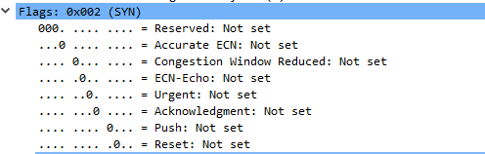

페

이 지P AG E

\* M

### Filter SYN, ACK packet

* 1. Filter SYN, ACK packet : tcp.flags.syn ==1 && tcp.flags.ack ==1

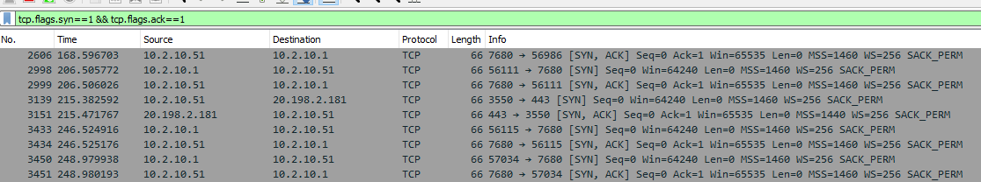

* 1. Analyze [SYN, ACK] packet

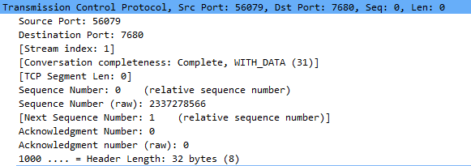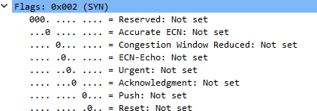

### Filter ACK packet

페

이 지P AG E

\* M

* 1. Filter ACK packet: tcp.flags.syn ==1 or tcp.flags.ack ==1 or (tcp.flags.syn ==1 and tcp. flags.ack ==1)

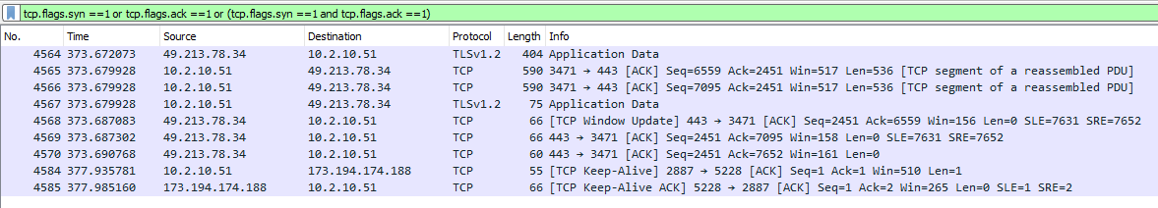

* 1. Analyze [ACK] packet

**LAB 05 wireshark2**

|  |  |
| --- | --- |
| Name | Tran Dang Khoa |
| Email address | [Khoab2014926@student.ctu.edu.vn](mailto:Khoab2014926@student.ctu.edu.vn) |
| Class | MO2 |
| Browser | Safari, Chrome, IE, Firefox |

**Design** Wireshark analyzing **scenario under Windows**

|  |  |  |
| --- | --- | --- |
|  | scanner | target |
| OS | Windows Ubuntu | Windows, Linux |
| IP address | Test - bed host IP | Localhost CTU IP CICT IP  Neighboring PC IP  VM IP(Ubuntu, Centos) |
| scanning program | Wireshark |
| scanning types | filter HTTP |

HTTP executing scenario

1. (browser) Visit one website

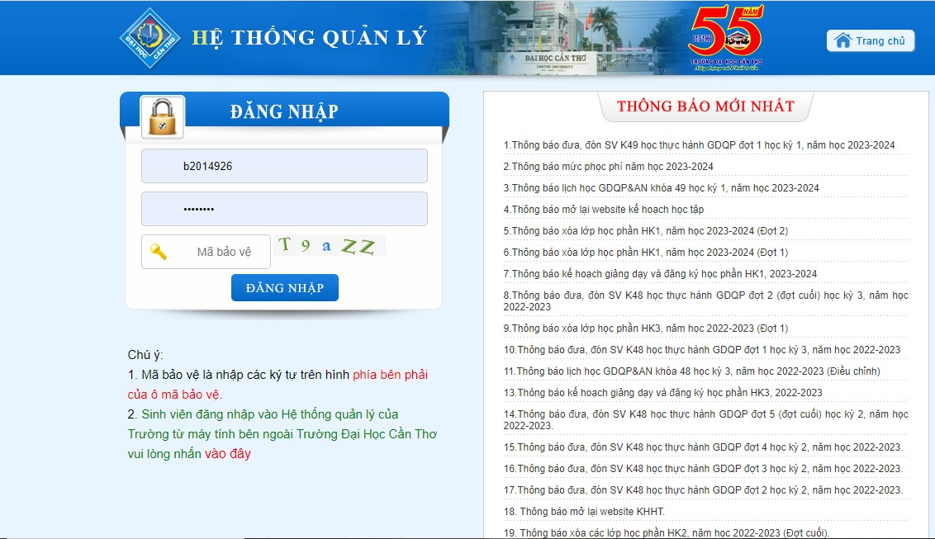

1. (website) Log in to home page

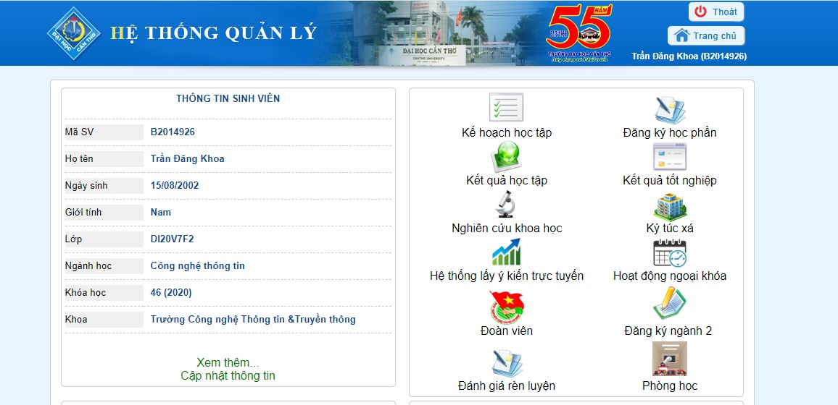

1. (browser) find input string on URL box



1. (wireshark) choose one packet

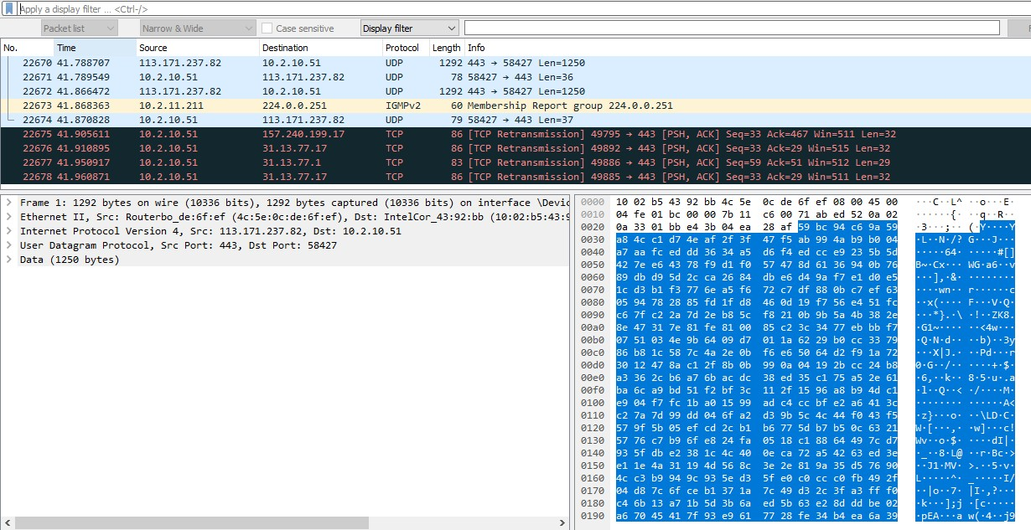

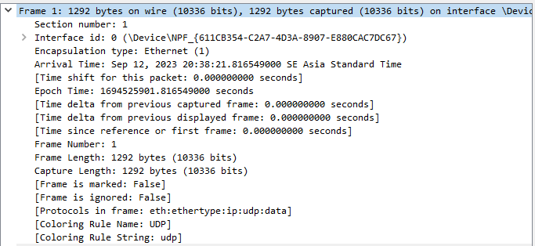

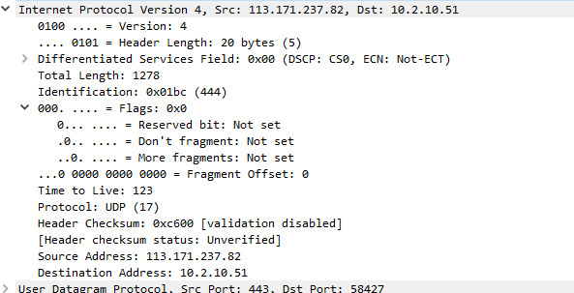

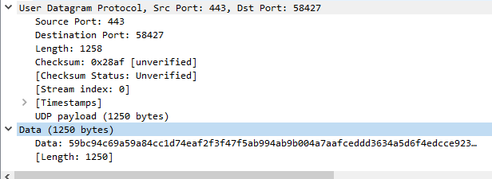

1. (wireshark) filter : get method

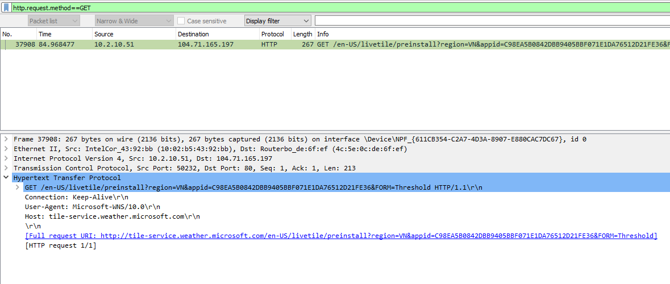

1. (wireshark) analyze get method in detail

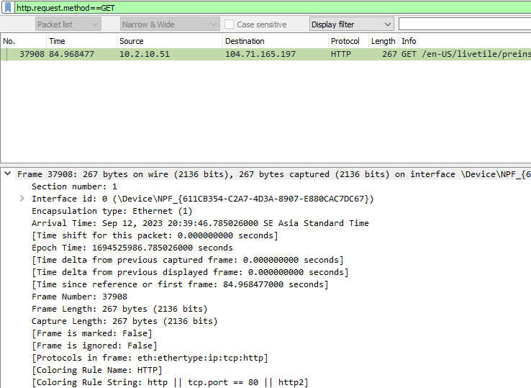

I choose frame 37908. There are 267 bytes on wire and being captured.

* + The interface id is 0 (\Device\NPF_{611CB354-C2A7-4D3A-8907-E880CAC7DC67})
  + Epouch time: 1694525986.785026000 second
  + Frame number is 37908
  + Frame Length: 267 bytes (2136 bits)

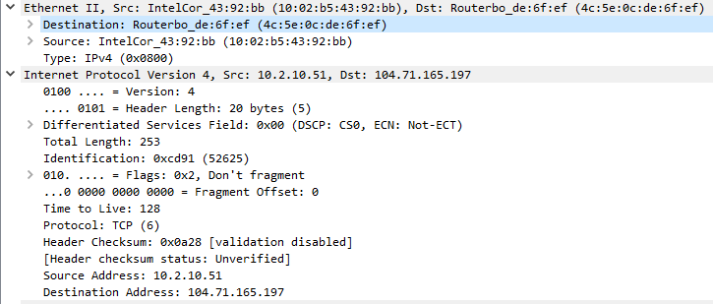

Ethernet II, Src: IntelCor_43:92:bb (10:02:b5:43:92:bb), Dst: Routerbo_de:6f:ef (4c:5e:0c:de:6f:ef)

Destination: Routerbo_de:6f:ef (4c:5e:0c:de:6f:ef) Source: InterCol_43:92:bb (10:02:b5:43:92:bb)

Type: Ipv4 (0x0800)

* + - Internet Protocol Version 4
    - Source address: 10.2.10.51
    - Destination address: 104:71:165:197
    - Total Length: 253
    - Identification: 0xcd91 (52625)
    - Time to Live: 128
    - Protocol: TCP (6)
    - Header Checksum: 0x0a28 [validation disabled]
    - Header checksum status: Unverified

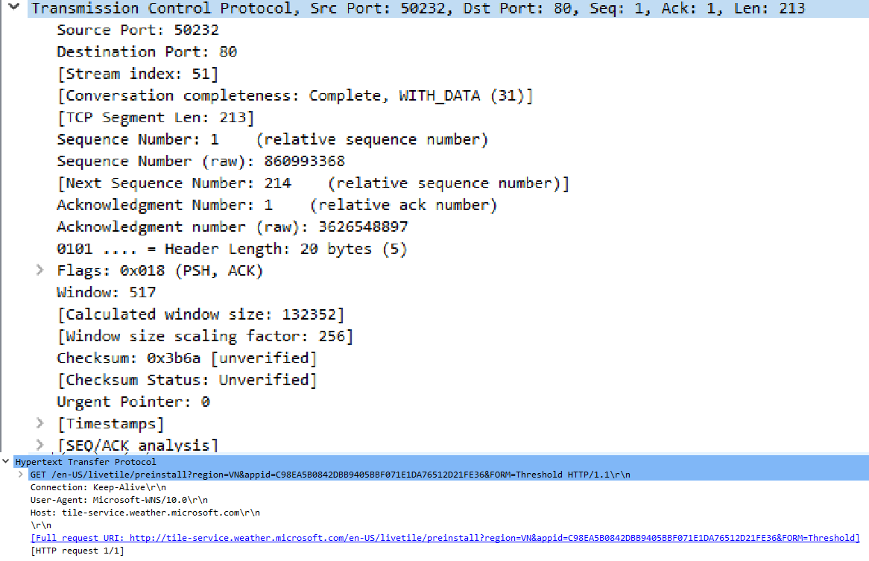

Transmission Control Protocol, Src Port: 50232, Dst Port: 80, Seq: 1, Ack: 1: Len: 123

Flags: 0x018 (PSH, ACK)

The HTTP field shows the host and ‘full request URI)

1. (wireshark) choose one packet

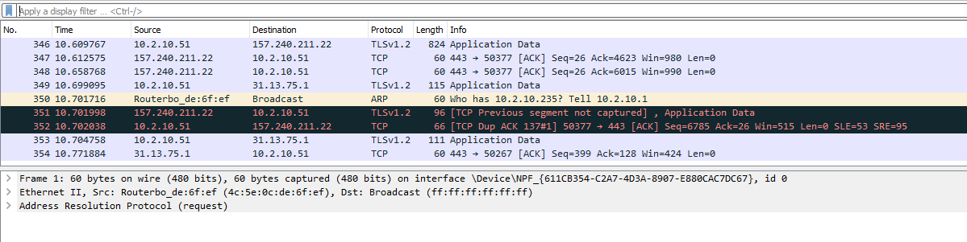

1. (wireshark) filter : post method

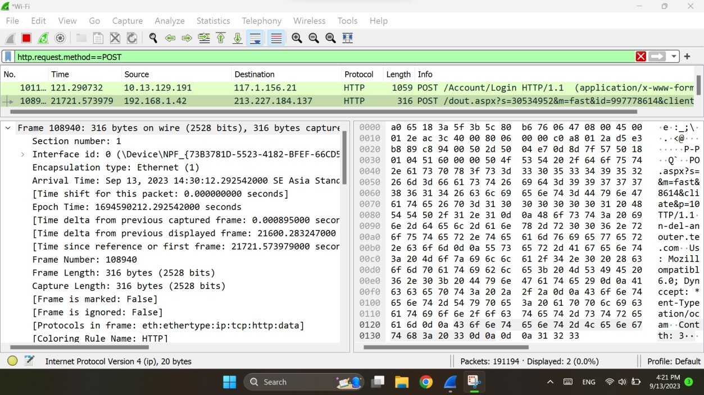

1. (wireshark) analyze post method in detail

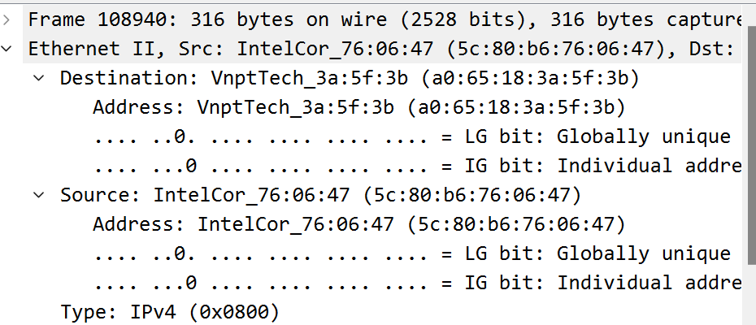

I chose frame 108940: 316 bytes on wire (2528 bits), 316 bytes capture

* + Interface id: 0 (\Device\NPF_{738371D-5523-4182-BFEF-77CD5)
  + Epoch Time: 1694590212.292542000 seconds
  + Frame Number: 108940
  + Frame Length: 316 bytes (2528 bits)

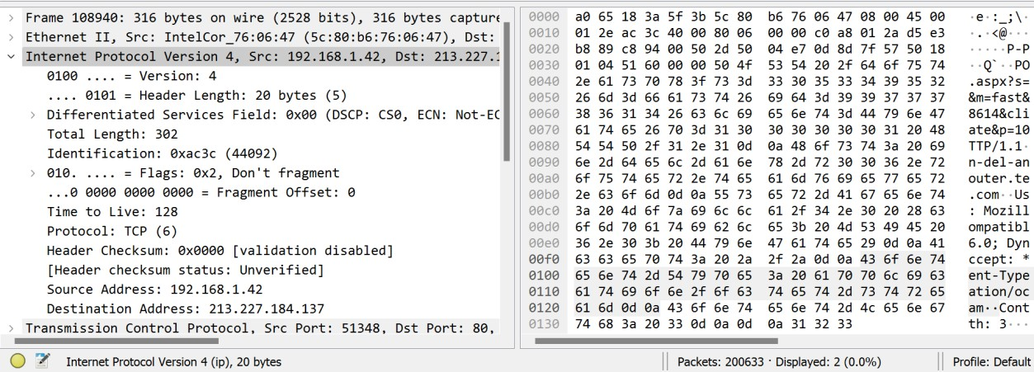

Internet Protocol Version 4, Src: 192.168.1.42, Dst: 213.227.2

* + Total Length: 302
  + Time to Live: 128
  + Protocol: TCP (6)
  + Header Checksum: 0x000 [validation disabled]
  + [ Header checksum status: Unverified]
  + Source Address: 192.168.1.42

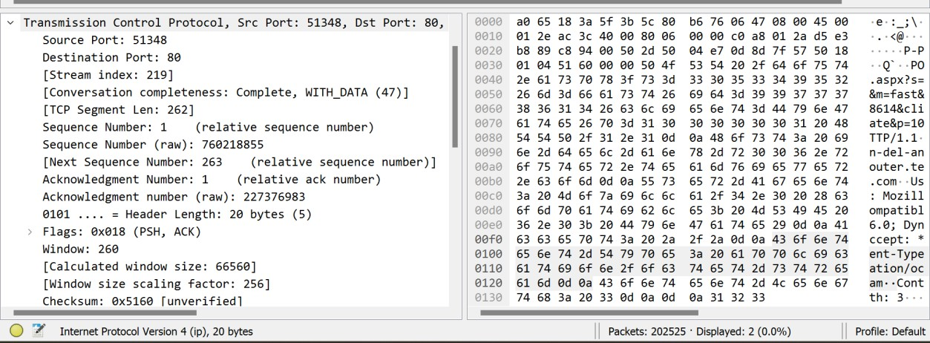

Transmission Control Protocol, Src Port: 51348, Dst Port: 80

* + Source Port: 51348
  + Distination Port: 80
  + [Stream index: 219]
  + [TCP Segment Len: 262]
  + Sequence Number: 1 ( relative sequence number)
  + Sequence Number (raw): 760218855
  + [Next Sequence Number: 273 (relative sequence number)
  + Acknowlegment Number: 1 (relative ack number)
  + Flags: 0x018 (PSH, ACK)

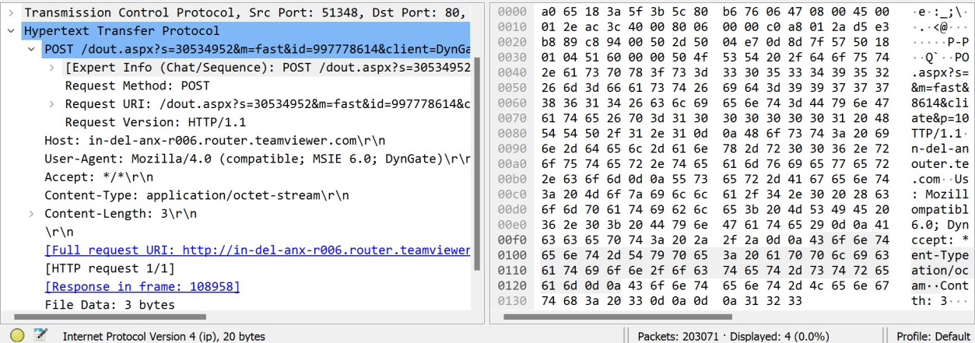

The HTTP field shows some information about POST method like User-Agent, Enconding, Postman-Token, Connectopn. More information full request URI, HTTP request 1/1.

**LAB06 Linux Firewall exercise**

|  |  |
| --- | --- |
| Class | M02 |
| Student ID | B2014926 |
| Name | Tran Dang Khoa |
| Email address | [Khoab2014926@student.ctu.edu.vn](mailto:Khoab2014926@student.ctu.edu.vn) |
| Class |  |
| Browser | Safari, Chrome, IE, Firefox |

Exercise following command, explain the command

##### Step 1 - Installing Iptables

① Update the package list by running the following command:

**Explain:** ‘sudo apt-get update’ is used to update system's knowledge of available software packages, which is essential before performing package installations or upgrades to ensure we are working with the latest package information

*$sudo apt-get update*

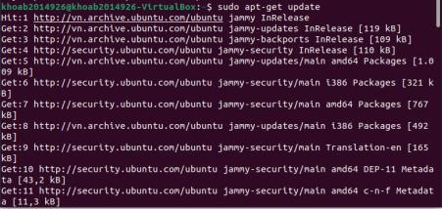

② Install iptables by running the following command:

**Explain:** ‘sudo apt-get install iptables’ installs the "iptables" package, which allows to configure and manage the firewall rules on your Linux system

*$sudo apt-get install iptables*

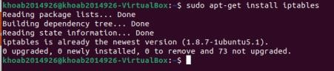

③ Verify the installation by checking the version of iptables:

*$iptables –version or $iptables -V (example below)*

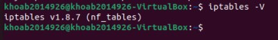

④ Show a list of all the rules in the fire wall

*$sudo iptables –L –v*

#### Explain:

iptables: command to manage the iptables firewall

-L or --list: This option is used to list and display the firewall rules for each chain (INPUT, OUTPUT, FORWARD, etc.).

-v or --verbose: This option provides more detailed information about the rules, including packet and byte counters.

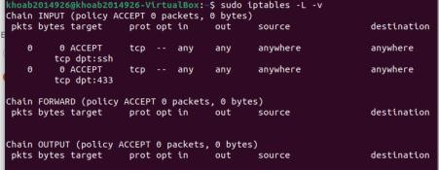

##### Step 2 - Defining Chain Rules

⑤ Insert the –A option (Append) right after the iptables command:

$sudo iptables -A

#### Explain:

**With some option:**

+ -i (interface) – the network interface you wish to filter traffic from

+ -p (protocol) – the network protocol where your filtering process takes place

+ -s (source) – the address from which traffic comes from. May be a hostname or IP address

+ --dport (destination port) – the destination port number of a protocol,

example 22 (SSH), 433 (https),...

+ -j (target) – the target name (ACCEPT, DROP, RETURN). You should to insert every time you make new rule

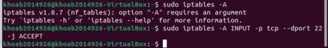



#### Enabling traffic on Localhost

⑥ The `-i lo` option specifies the loopback interface, and the `-j ACCEPT` option allows the traffic

*$sudo iptables –A INPUT –i lo –j ACCEPT*

#### Explain:

-A INPUT: This specifies that you want to append (add) a rule to the INPUT

chain.

-i lo: It specifies the network interface to which the rule applies, in this case, the loopback interface (lo).

-j ACCEPT: This part of the rule specifies the action to take when traffic matches the rule, which is to ACCEPT the traffic.



⑦ Check that the new rule was added:

*$sudo iptables –L INPUT –v –n*

#### Explain:

-L INPUT: This specifies that you want to list and display the rules for the INPUT chain.

-v or --verbose: This option provides more detailed information about the rules, including packet and byte counters.

-n or --numeric: This option displays IP addresses and port numbers in numeric format instead of resolving them to hostnames and service names.

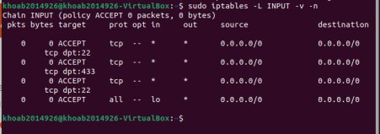

#### Enabling conntections on HTTP, SSH and SSL port

⑧ To enable incoming connecton on HTTP (port 80), SSH (port 22), and SSL (port 443) using iptables on Ubuntu. Add rules to allow incoming traffic on HTTP, SSH, and SSL port:

*$sudo iptables –A INPUT –p tcp –dport 80 –j ACCEPT*

*$sudo iptables –A INPUT –p tcp –dport 22 –j ACCEPT*

*$sudo iptables –A INPUT –p tcp –dport 443 –j ACCEPT*

#### Explain:

These commands allow incoming TCP traffic on port 80, 22 and 443, which is commonly used for web server traffic. It's a common rule in firewall configurations to allow HTTP traffic to reach a web server hosted on the system

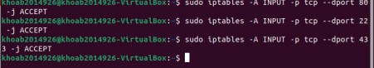

⑨ And use command to check:

*$sudo iptables –L –v*

#### Explain:

-L or --list: This option specifies that you want to list and display the

rules for all chains (INPUT, OUTPUT, FORWARD, etc.).

-v or --verbose: This option provides more detailed information about the rules, including packet and byte counters**.**

Get a detailed listing of the current firewall rules for all chains, including rule numbers, target actions, protocol, source and destination IP addresses, source and destination ports, and packet and byte counters. This command is useful for inspecting the current firewall configuration and monitoring traffic statistics

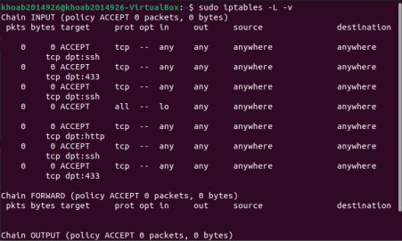

#### Filtering packets based on Source

⑩ Filter packets based on source IP addresses in iptables by adding a rule that matches packets based on their source address.

*$sudo iptables –A INPUT –s 192.168.1.100 –j DROP*

#### Explain:

--s 192.168.1.100: This specifies the source IP address for the rule, which is 192.168.1.100. Any incoming traffic originating from this IP address will be affected by this rule.

-j DROP: This part of the rule specifies the action to take when traffic matches the rule, which is to DROP (block) the traffic.

This command blocks all incoming traffic from the IP address 192.168.1.100 by appending a rule to the INPUT chain that drops any packets coming from that specific source IP address. This can be used to restrict or deny incoming connections from a particular source.

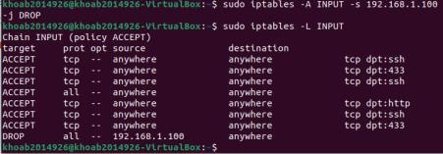

#### Dropping all Other traffic

⑪ Add a default DROP rule to the firewall's INPUT, OUTPUT, and FORWARD chains to drop all other traffic.

$sudo iptables –A INPUT –j DROP

#### Explain:

This command effectively blocks all incoming traffic to your system by appending a rule to the INPUT chain that drops all packets

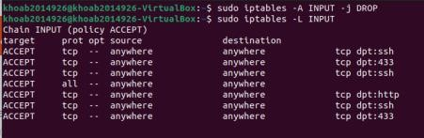

#### Deleting rules

⑫ Remove all rules and start with a clean slate, you can use the option –F (flush):

*$sudo iptables –F*

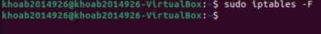

⑬ To delete a specfc rule in iptables, use the `iptables –D` command

*$sudo iptables –L –line-numbers*

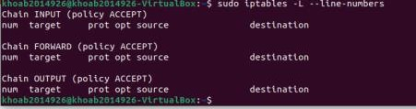

⑭ Delete the rule with command

*$sudo iptables –D <chain> <line_number>*

*$sudo iptables –D INPUT 3*



##### Step3 - Persisting Changes

⑮ To make these **changes presistent** after restarting the server:

*$sudo /sbin/iptables-save*

**Explain:** This command is used to save the current iptables rules

⑯ Disable iptables, we need to execute following commands:

*$sudo iptable –F*

*$sudo /sbin/iptables-save*

LAB07 PoD simulation

|  |  |
| --- | --- |
| Class | M02 |
| Student ID | B201926 |
| Name | Trần Đăng Khoa |
| Email address | [Khoab2014926@student.ctu.edu.vn](mailto:Khoab2014926@student.ctu.edu.vn) |
| Browser | Safari, Chrome, IE, Firefox |

#### Design test environment

|  |  |  |
| --- | --- | --- |
|  | Attacker | Target |
| OS | Windows 10 | Ubuntu |
| IP address | Test - bed IP | Test - bed IP |
| Attacking type | Ping of Death with 65000bytes |  |
| Program for attacking | **Powershell, CMD** |  |
| Command for monitoring |  | Gnome, netstat |

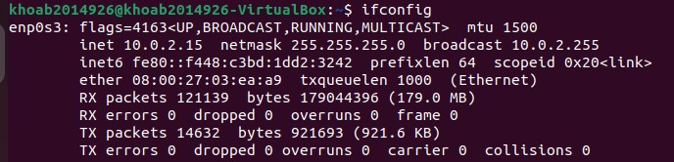**[Powershell] Taget:**

On attacker:

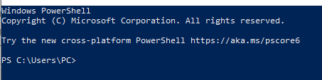① Install **Powershell on attacker system**

② Send 65000-byte packets 5 times to ubuntu server using CMD ping command, **Powershell**:

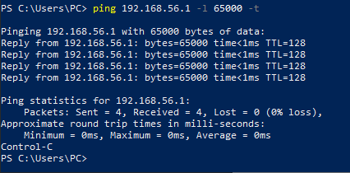

Option: **Powershell**

* + -t means the data packets should be sent until the program is stopped
  + -l specifies the data load to be sent to the victim

- every few seconds this network receives about ~50kb, and it does not respond (sending – red line), because the packet size is exceeded, it cannot be processed

#### [PS to localhost]

**PS C:\Users\Happy> ping localhost -l 100 -t**

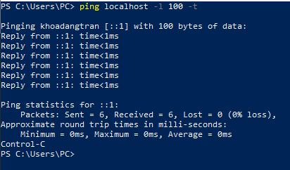**Control-C**

**[PS to CTU] PS C:\Users\Happy> ping 182.172.255.180 -l 100 -t**

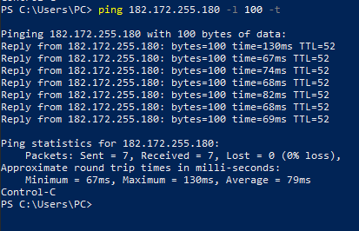**Control-C**

CMD

Option: CMD

* + -t means the data packets should be sent until the program is stopped •

-l specifies the data load to be sent to the victim

On target:

every few seconds this network receives about ~50kb, and it does not respond (sending – red line), because the packet size is exceeded, it cannot be processed

③ Install Linux monitoring software Gnome on target and analyze target system Explain: To install GNOME System Monitor on Ubunt

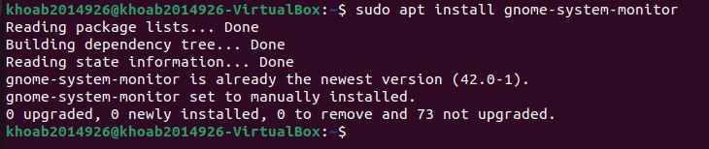

Check the traffic volume of target system using relevant tool

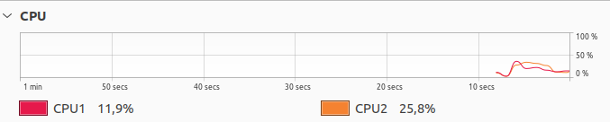

④ Install CMD net-tools package on Ubuntu and explain attacking result

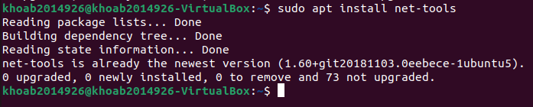

⑤ Detect DoS attack Symptom on the target system with CMD netstat commands

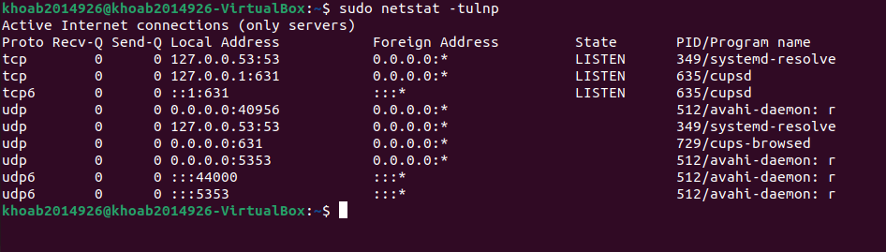

⑥ Block DoS attack IP on Ubuntu using commands iptables (snap shot) and explain blocking result

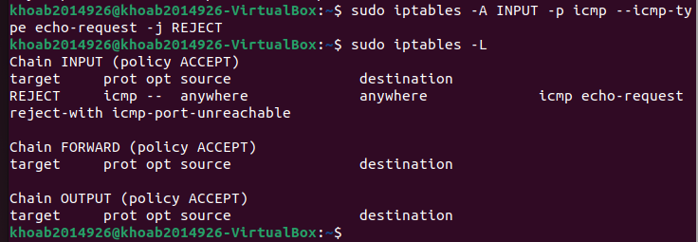

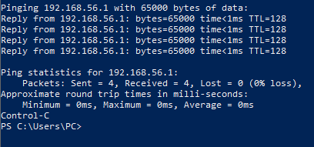

Explain:

Pinging 192.168.56.1 with 65000 bytes of data: Send ICMP echo requests (ping) to the IP address "192.168.56.1"

Reply from 192.168.56.1: Destination port unreachable: The server at IP address "192.168.56.1" received your ICMP echo requests but responded with "Destination port unreachable" messages.

* ICMP is a network protocol used for various network-related messages, including "ping."
* The "Destination port unreachable" message typically indicates that the destination (the server) received the packet but couldn't find a listening service or port to which it should be delivered.

Ping Statistics: The statistics at the end of the output provide information about the ping operation:

* "Packets: Sent = 4": Sent 4 ICMP echo requests.
* "Received = 4": Received 4 responses.
* "Lost = 0 (0% loss)": None of the packets were lost in transit, indicating that all 4 ICMP echo requests reached the destination and received responses.

⑦ Explain how to Block/Allow ping from iptables? Block Ping

*$sudo iptables -A INPUT -p icmp --icmp-type echo-request -j REJECT*

Explain: the command sudo iptables -A INPUT -p icmp --icmp-type echo-request -j REJECT adds a rule to the INPUT chain of iptables that rejects all incoming ICMP echo requests. This means that no other hosts on the network will be able to ping your computer. -A INPUT: This appends the rule to the INPUT chain, which handles incoming packets.

-p icmp: It specifies that the rule applies to the ICMP protocol.

--icmp-type echo-request: This further specifies the rule to match ICMP echo requests (ping requests).

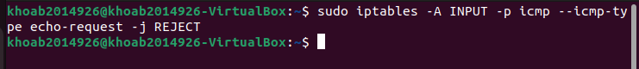-j REJECT: This means that any incoming ICMP echo request packets will be rejected and not allowed to reach their destination. The sender of the ICMP echo request will receive an ICMP "Destination Unreachable" message in response.

Or else, you can add the following rules in order to block ping without printing an error message:

*$sudo iptables -A INPUT -p icmp --icmp-type echo-request -j DROP*

Explain: the command sudo iptables -A INPUT -p icmp --icmp-type echo-request -j DROP adds a rule to the INPUT chain of iptables that drops all incoming ICMP echo requests. This means that no other hosts on the network will be able to ping your computer.

-j DROP: This part of the command instructs the firewall to drop (discard) any incoming ICMP echo request packets.

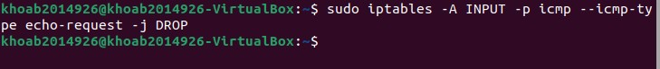

Allow Ping

*$ sudo iptables -L*

Explain: The command sudo iptables -L lists all of the current iptables rules

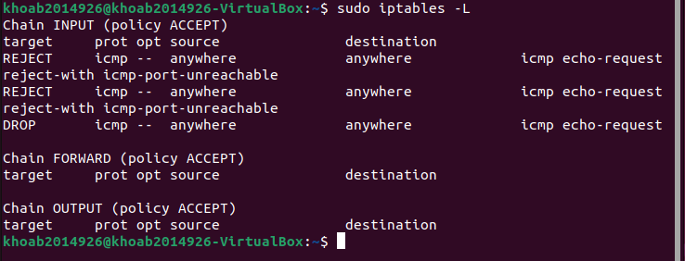

⑧ If any of the rules is blocking ping (in our case ICMP is rejected), you can simply remove that rule as follows:

*$ sudo iptables -D INPUT -p icmp --icmp-type echo-request -j REJECT*

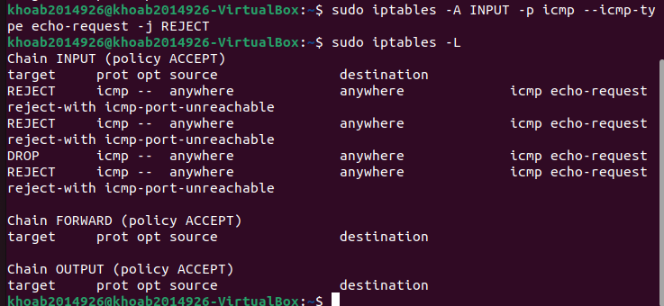

⑨ Delete all custom rules added to your iptables Firewall

$ sudo iptables -F

Explain: The command sudo iptables -F flushes all of the current iptables rules

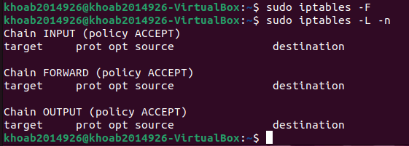

**LAB 09: DoS simulation with Python**

|  |  |
| --- | --- |
| Class | M02 |
| Student ID | B2014926 |
| Name | Tran Dang Khoa |
| Email address | [Khoab2014926@student.ctu.edu.vn](mailto:Khoab2014926@student.ctu.edu.vn) |
| Class | M02 |
| Browser |  |

1. Test environment setting

|  |  |  |
| --- | --- | --- |
|  | Attacker | Target |
| OS | Ubuntu | Window 10 |
| Ip address | Test bed | Test bed |
| Attacking type | Ping flooding SISP |  |
| Attacking program | Python Scapy |  |
| Detecting program | Wireshark | Wireshark |
| Blocking program |  | Window firewall |
| Analyzing program |  | netstat commands  task manager |

1. Exercise following process

① Install python on Linux:

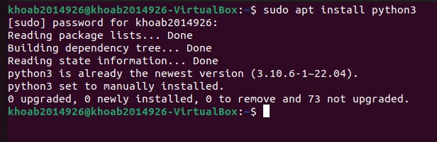

② Install Scapy on Linux

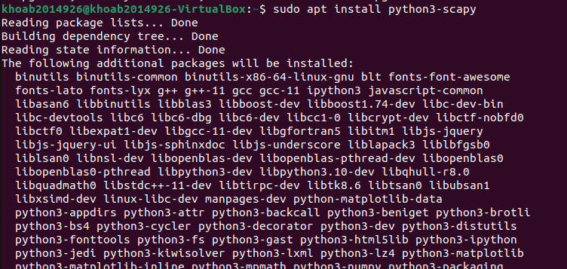

③ Code DoS program : single IP single port

[**https://www.tutorialspoint.com/python_penetration_testing/python_penetration_testing_dos_and_ddos_a**](https://www.tutorialspoint.com/python_penetration_testing/python_penetration_testing_dos_and_ddos_attack.htm)[**ttack.htm**](https://www.tutorialspoint.com/python_penetration_testing/python_penetration_testing_dos_and_ddos_attack.htm)

#!/bin/usr/env python from scapy.all import *

source_IP = input("Enter IP address of Source: ") target_IP = input("Enter IP address of Target: ") source_port = int(input("Enter Source Port Number:")) i = 1

while True:

IP1 = IP(src = source_IP, dst = target_IP) TCP1 = TCP(sport = source_port, dport = 80) pkt = IP1 / TCP1

send(pkt, inter = .001)

print ("packet sent ", i) i = i + 1

④ Install Nano editor on Python with Name dos.py:

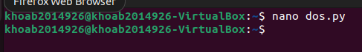

⑤ Input DoS code manually or paste into Nano sceen

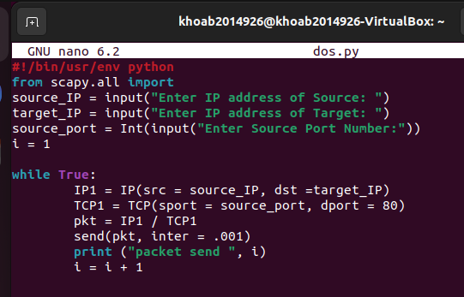

⑥ Run dos.py:

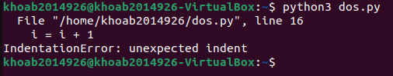

IP of attacker:127.0.0.1

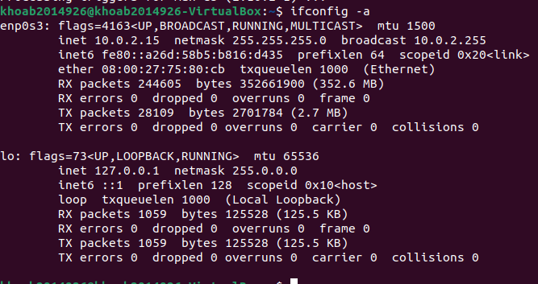

IP of target:192.168.56.1

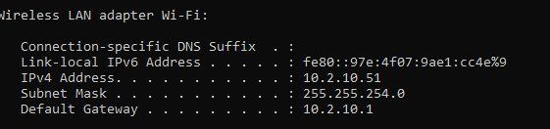

⑦ Check with Wireshark if the victim system is congested, explain

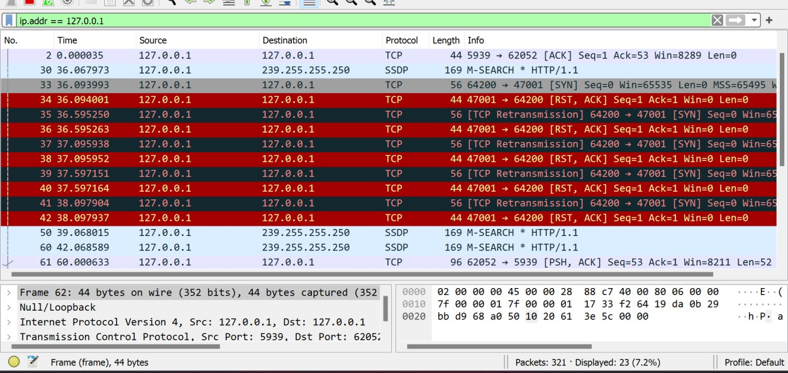

Explain: There are many packets are being continuously sent from 127.0.0.1 to 192.168.56.1 with port 8888, indicating congestion caused by the DoS attack.

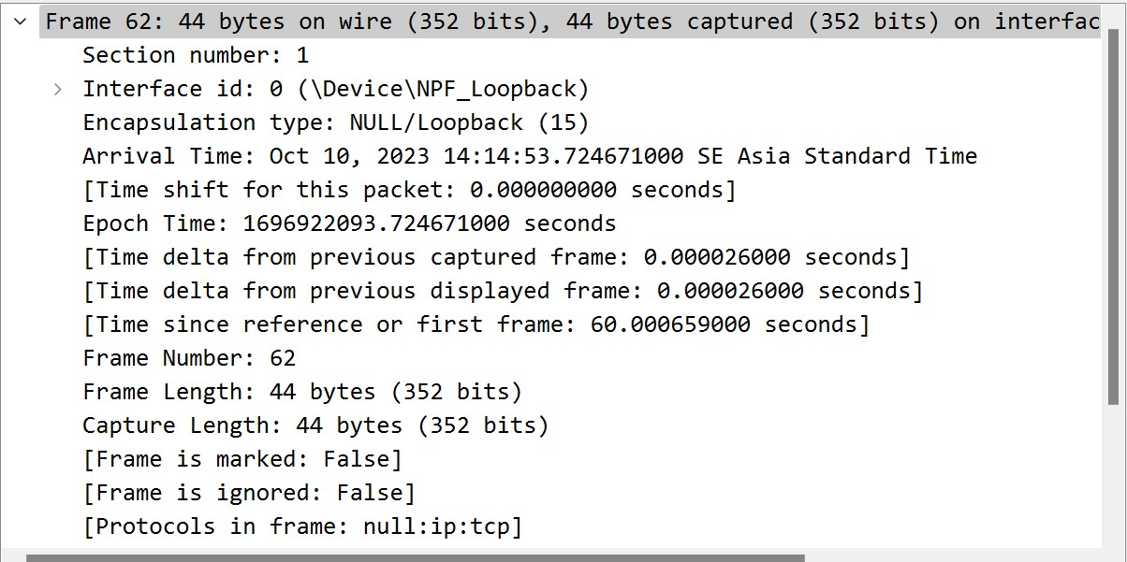

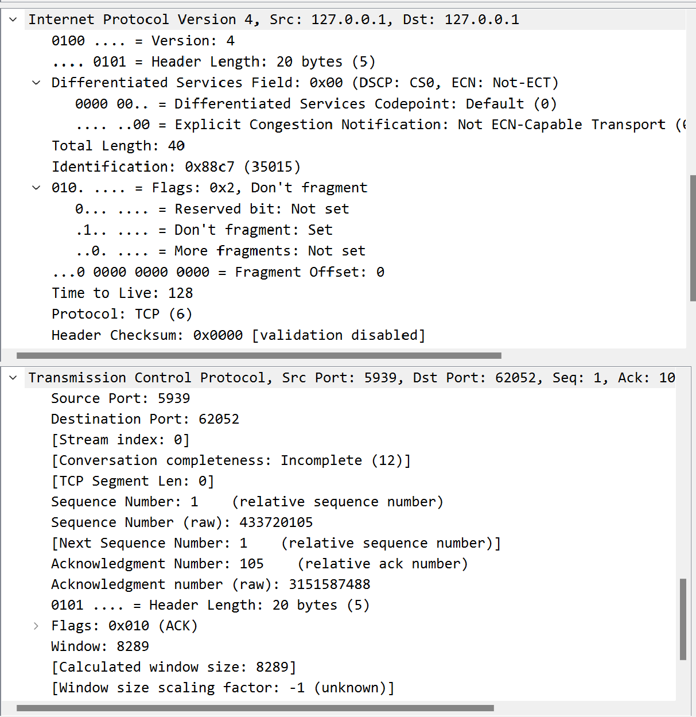

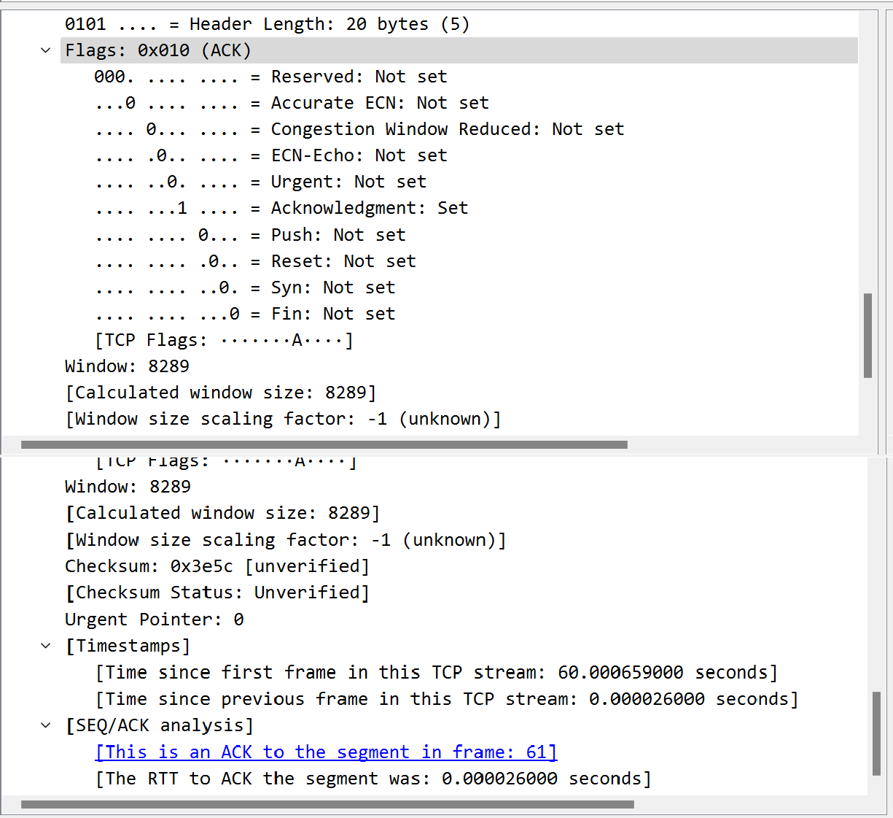

# LAB11A SQL injection & avoiding

Class: M02

Name: Tran Dang Khoa Student ID: B2014926

### System environment for developing

|  |  |  |  |
| --- | --- | --- | --- |
| Resources | Sender(attacker) | Receiver(victim) | Homepage |
| OS |  |  |  |
| IP address |  |  |  |
| URL |  |  |  |
| Web browser |  |  |  |
| CSS language |  |  |  |
| Web server |  |  |  |
| Web application |  |  |  |
| DB server script |  |  |  |
| Others |  |  |  |

**Exercise following scenario on your terminal as far as you do,** (if you meet error please describe error message)

① Check the following software installed and enabled on your (pen-test) system:

[PHP 7](http://www.php.net/), [Composer](https://getcomposer.org/), PHP PDO Extensions for SQLite (and, optionally, for MySQL as well)

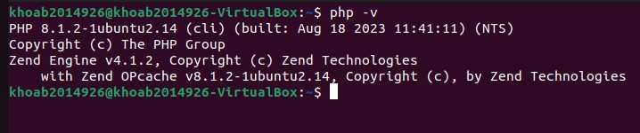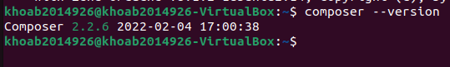

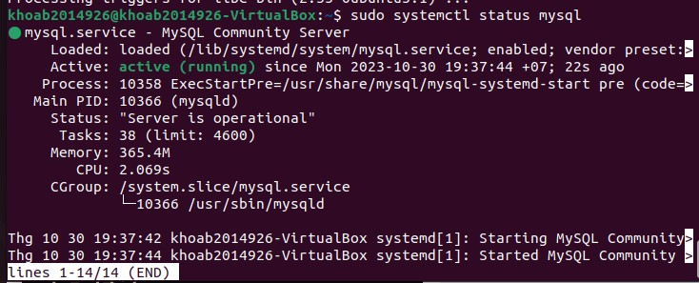

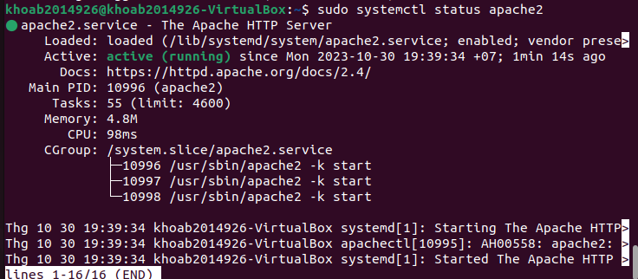

② [Set up and start the exploitable PHP application](https://developer.okta.com/blog/2020/06/15/sql-injection-in-php#set-up-and-start-the-exploitable-php-application)

③ Download the source code from [GitHub](https://github.com/oktadeveloper/sql-injection-in-php).

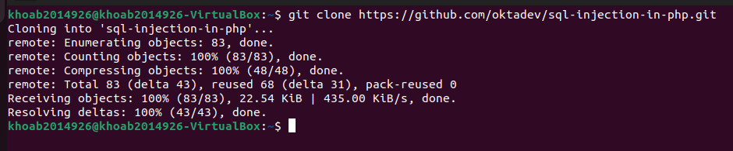

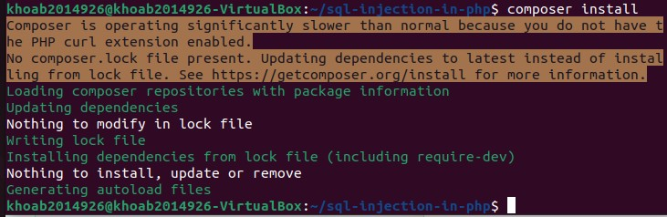

④ Execute the PHP built-in server in the port 8080 (you can choose another port if you wish):

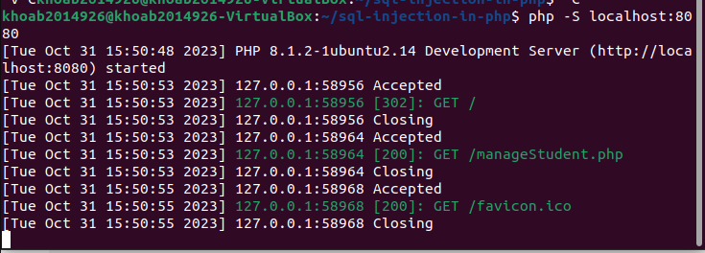

**⑤** Visit the vulnerable app from your browser by navigating to http://localhost:8080**.**

Reference

<https://developer.okta.com/blog/2020/06/15/sql-injection-in-php>

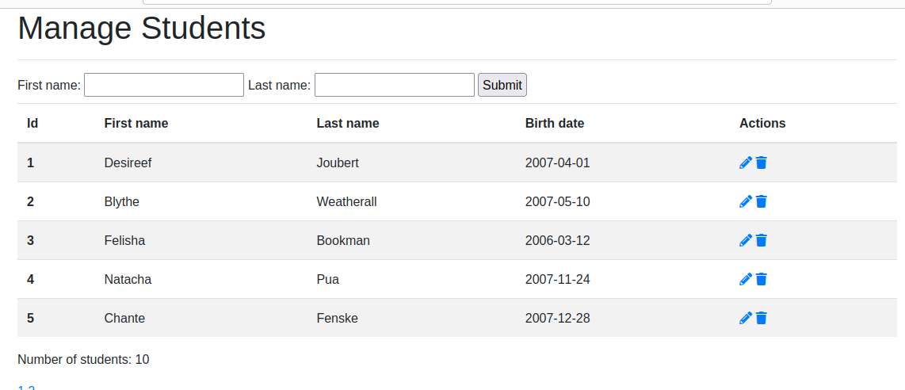

# LAB11B SQL injection & avoiding

|  |  |  |
| --- | --- | --- |
| Class | Name | Students ID |
| Class | Name | Students ID |

### System environment for developing

|  |  |  |  |
| --- | --- | --- | --- |
| Resources | Sender(attacker) | Receiver(victim) | Homepage |
| OS |  |  |  |
| IP address |  |  |  |
| URL |  |  |  |
| Web browser |  |  |  |
| CSS language |  |  |  |
| Web server |  |  |  |
| Web application |  |  |  |
| DB server script |  |  |  |
| Others |  |  |  |

**Exercise following scenario as far as you do**

① Explain how to search PHP code that contains an SQL Injection vulnerability?

* To search for PHP code contains SQL Injection Vulnerability, we can find the code that accepts user input (in thí case, from a GET parameter) and includes it directly in the SQL statement. This allows an attacker to inject SQL in the query, therefore tricking th e application into sending a malformed query to the database.

<https://www.acunetix.com/blog/articles/prevent-sql-injection-vulnerabilities-in-php-applications/>

② Survey and explain web application database query model for SQL injection test

* Injection based on 1=1 is always True: if the coder don’t prevent wrong input, attacker can enter some input like:

<https://www.w3schools.com/sql/sql_injection.asp> .

-

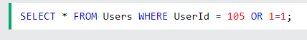

-SQL injection Ba on “”=”” is Always True: attacker can enter some input like

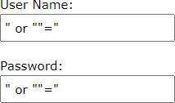

* The sql statement will become

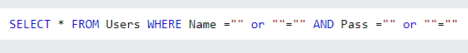

+ A batch of SQL statements is a group of two or more SQL statements, separated by semicolons

+ The attack can delete our database by entering some input like:



+ The SQL will be:



③ Survey and explain SQL Injection Prevention in PHP

[https://www.acunetix.com/blog/articles/prevent-sql-injection-vulnerabilities-in-php-ap](https://www.acunetix.com/blog/articles/prevent-sql-injection-vulnerabilities-in-php-applications/) [plications/](https://www.acunetix.com/blog/articles/prevent-sql-injection-vulnerabilities-in-php-applications/)

<https://developer.okta.com/blog/2020/06/15/sql-injection-in-php>

To prevent SQL Injection

* Santizing your inputs. Don’t ever trust incomming data. Before even pro cessing the database query, validate user input – When dealing with SQ L queries that contain user input, use prepared statements also known as parameterized queries.
* Do not display SQL errors to the user. If you need to show the user an error, use a generic error massage that does not give away sensitive in formation.
* Don’t rely on client-side input sanitation. An attacker could launch SQL Injection attacks emulating the calls from a browser, using unsanitized d ata.

➃ S[et up and start the exploitable PHP](https://developer.okta.com/blog/2020/06/15/sql-injection-in-php#set-up-and-start-the-exploitable-php-application), my SQL, test data

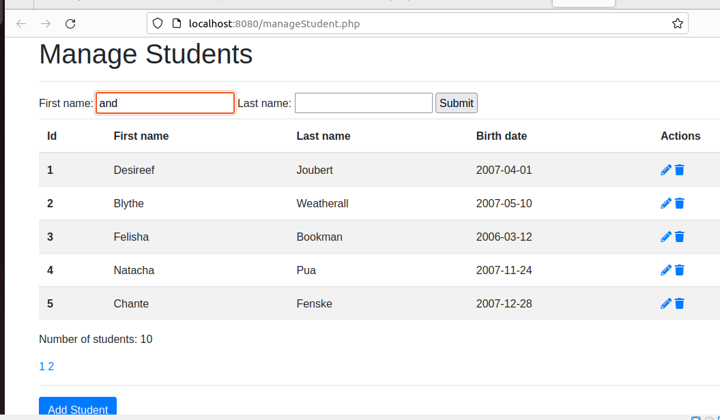

⑤ Select one test run step among 1,2,3 steps for SQL injection & avoiding test (if you meet error please describe error situation)

In the first test try searching for students including the following first name; ‘and birth_date<’2007-10-10’;--.

-

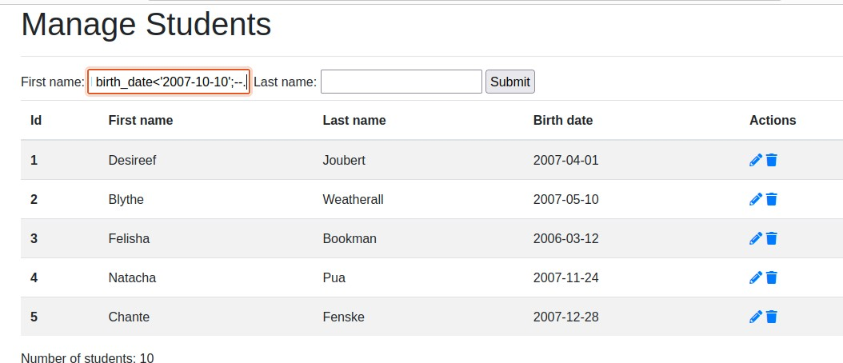

* In the next test step: we search for students with the following last name: ‘or 1=1;--

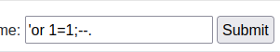

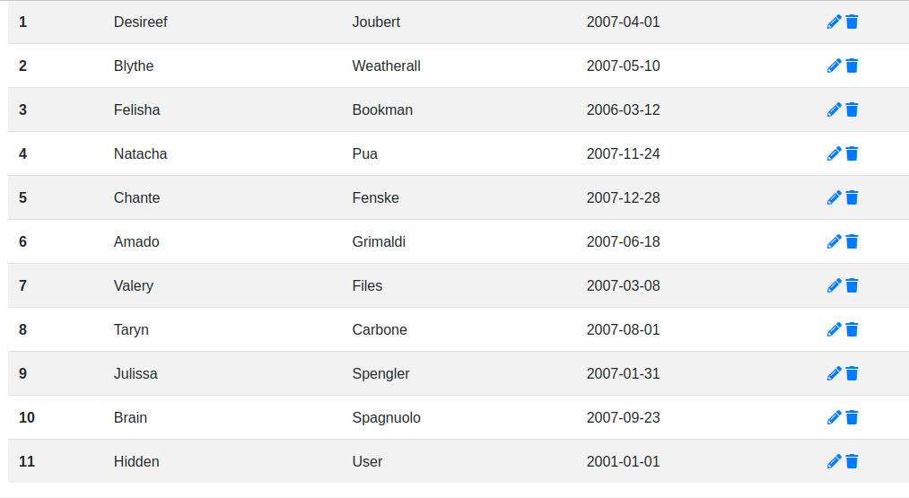

**LAB 12: SECURE CODING INPUT VALIDATION BY java**

Class: M02

Name: Tran Dang Khoa ID Student: B2014926

A in java

**1 *Execut following first secure coding, exercise as far as you can***

1. **Process designing**
2. **Coding**
3. **Executing**

|  |  |
| --- | --- |
| os |  |
| IDE | Terminal |
| language | Java 11 |
| Type of DB |  |
| Type of File |  |
| Other software |  |

**2**

**3 [Process designing]**

1 Configure the Complete Build Process

1. How to install/set up IDE for java, How to install/call java under IDE

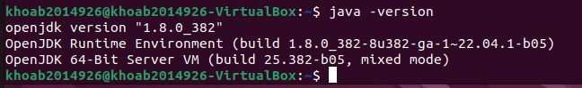

1. Search coding model ***java*** program,

<https://kodejava.org/how-do-i-validate-input-when-using-scanner/>

1. How to compile java program

<https://www.tutorialspoint.com/How-to-compile-a-java-program>

1. How to connect & interface input validation java module to main program
2. Explain the input validation program logic
   * Get the input from user
   * Check the input is integer or not
   * If not continue check the input is float or not
   * If not integer or float. The input is string
3. How to run the program

### [Coding]

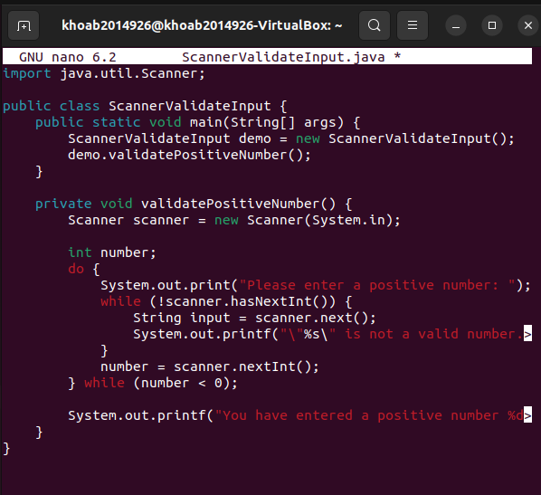

**[Executing]**

* + Compile Main.java to ScannerValidateInput file to execute
  + Run after compiling successfully and check the result

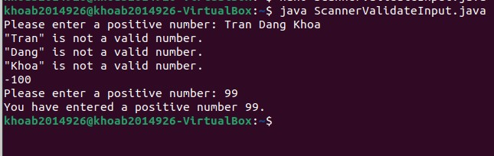

# LAB 13: Analyze system status

Class M02 Name Tran Dang Khoa Students ID B2014926

**System environment for analyzing**

|  |  |  |
| --- | --- | --- |
| Window tool | Linux command | Remarks |
|  |  |  |
| Process Explorer |  |  |
| CurrPorts |  |  |
| Process Monitor |  |  |
| Tcpview |  |  |
|  |  |  |

# Select one model and exercise

[A]: Execute Process Explorer and analyze the system status 1 Invesgate & practice Linux command or package to check

what process in system, which process is using higher memory or CPU, how long a process is running, List of running backgrounds, process ID

statistics of virtual memory, kernerl threads, disks, system processes,

I/O blocks, interrupts, CPU activity

**top – Linux Process Monitoring**

* Dipslay all the running and active real-time processes in ordered list and updates it regularly.
* CPU usage, Memory usage, Swap Memory, Cache Size, Buffer Size, Process PID, User, Commands and much more. It also shows high memory and cpu utilization of a running processess.

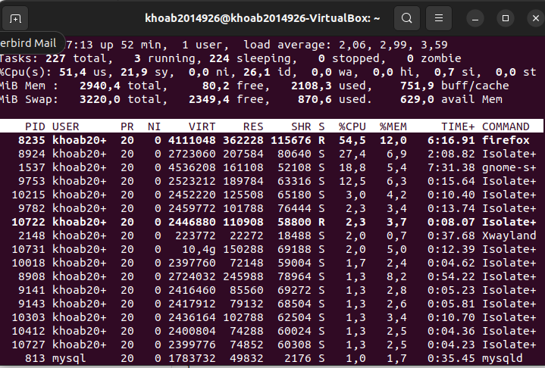

**Check the process status in real time with the following command.**

* + Through this process, it is possible to check abnormalities in the backrunning daemon

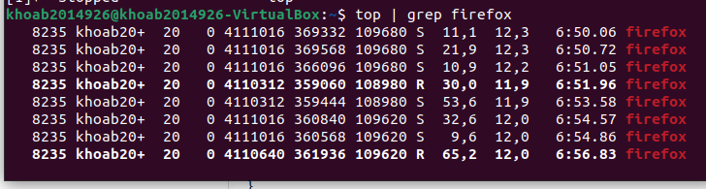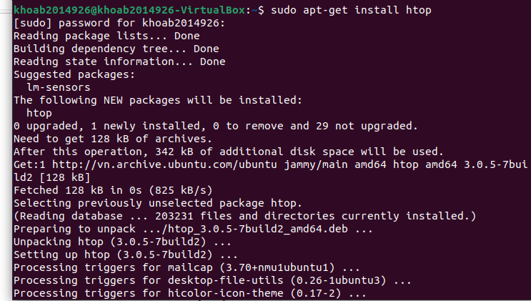

**Htop – Linux Process Monitoring**

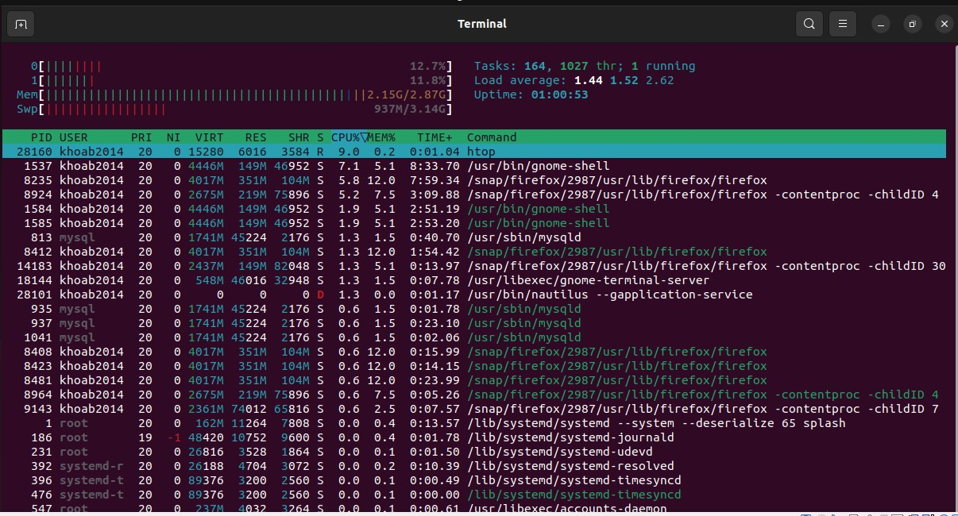

**process is using higher memory or CPU**



**Virtual Memory Statistics**

* + 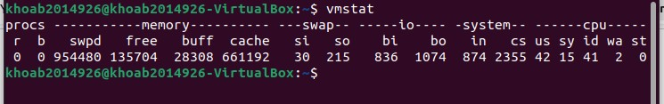Linux VmStat command used to display statistics of virtual memory, kernerl threads, disks, system processes, I/O blocks, interrupts, CPU activity and much more.

**Iotop – Monitor Linux Disk I/O**

* + Iotop is also much similar to top command and Htop program, but it has accounting function to monitor and display real time Disk I/O and processes.

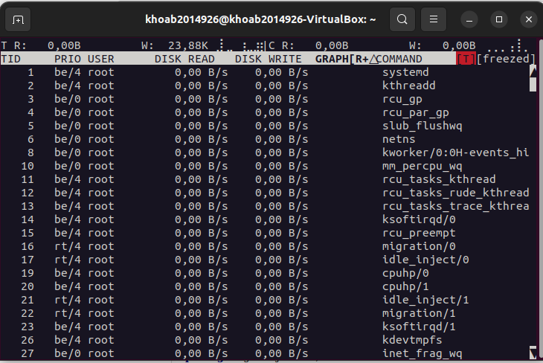

**ps aux command**

* + Arrange process list and check process status

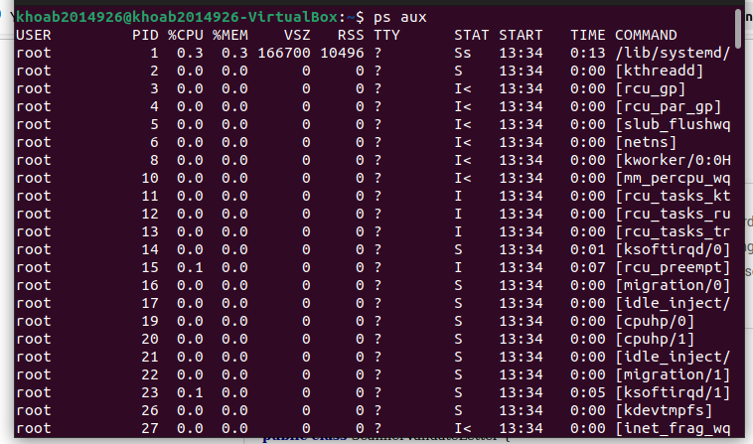

**Process Status**

* + Information on currently running processes

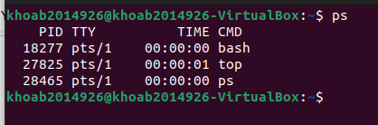

**Display whole process**

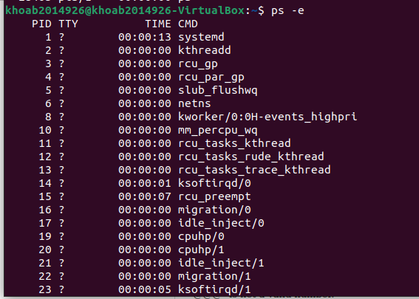

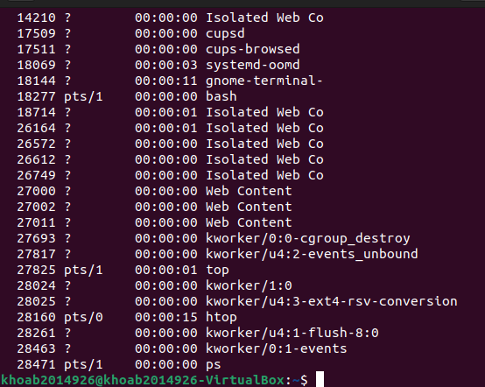

**Display full status information**

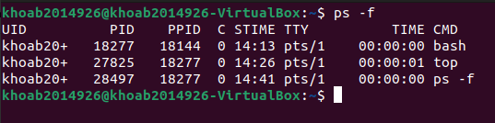

**Linux pipe**

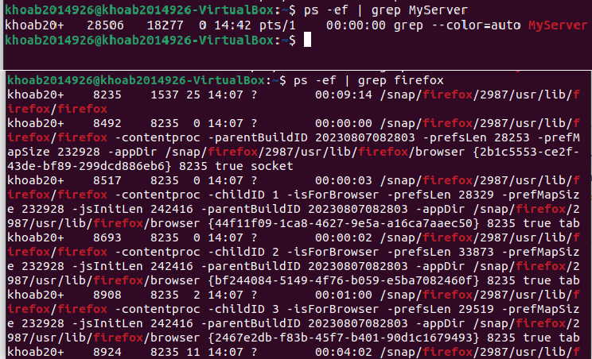

**Check running backgrounds**

List of running backgrounds

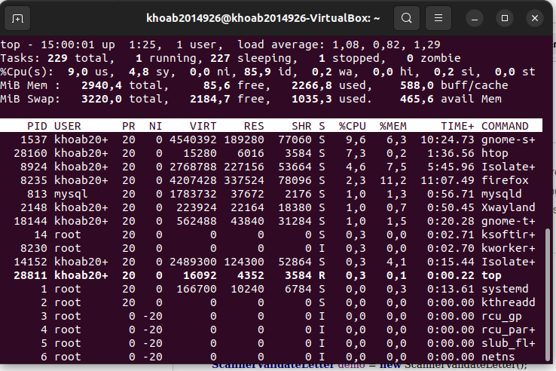

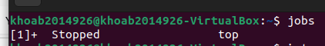

**More details with option -l. Unique job id Print process ID**

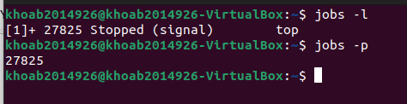

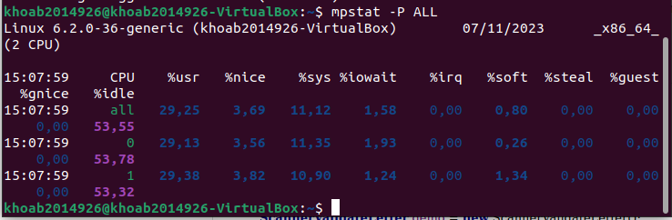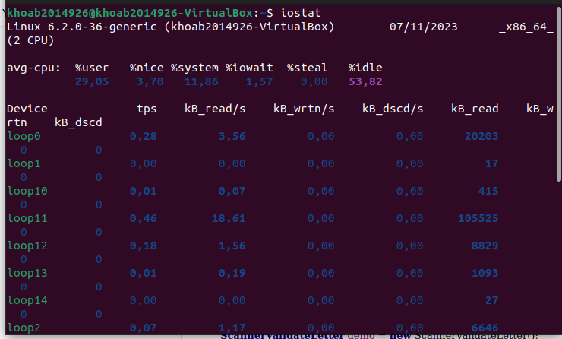

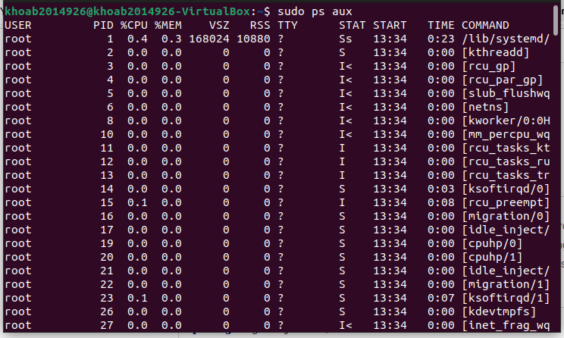

## LAB 14: VULNERABILITY ASSESSMENT

**Class M02 student ID b2014926 Name Tran Dang Khoa**

1. Design your scenario of vulnerability assessment

|  |  |  |
| --- | --- | --- |
| **No** | **Steps** | **Remarks** |
| 1 | Environment setting | Inspection area: Network vulnerable  Target: Ubuntu 14.04, Firefox, 172.19.128.128  Attacker: Virtual machine, Kali Linux, Firefox, (bridged adapter) |
| 2 | Choose one scanning model | B: Nmap vulners |
|  | Install scanning program | git clone https://github.com/vulnersCom/nmap-vulners.git |
| 3 | Run the program | sudo nmap -sV --script vulners.nse 172.19.128.128 |
| 4 | Analyze the result based on your idea | List up the vulnerability checking items Grade the vulnerability level |

1. Exercise the following vulnerability assessment process

|  |  |  |
| --- | --- | --- |
| N  o | Steps | Remarks |
| 1 | Environme nt  Setting | 1. Inspection area Network, Web vulnerable 2. Target: Ubuntu 14.04, Firefox, 172.19.128.128 3. Attacker: Kali Linux, Firefox, 172.19.128.22 |
| **2** | **Choose scanning program/t ool** | **Nmap vulners** |

|  |  |  |
| --- | --- | --- |
| **3** | **Set the scanning environme nt, command** | **Input target address on program/tool**  **Set the scanning options:** -sV --script vulners.nse 172.19.128.128 |
| **4** | **Execute the scanning program** | **Run the scanning program:**  **sudo nmap -sV --script vulners.nse 172.19.128.128** |
| **5** | **Print out scanning result** |  |
| **6** | **Analyze the result based on your idea** | Grade the vulnerability level:   * As we can have seen from the results above, the target machine vulnerability level is really high: 9 or 10   Explain the analyzing result:   * After running the program the script will look up records from several vulnerability database such as CVE, National Vulnerability, … to check and link the public vulnerability from the results of nmap. |

1. **Explain your scenario**

**-**Download if from Github:

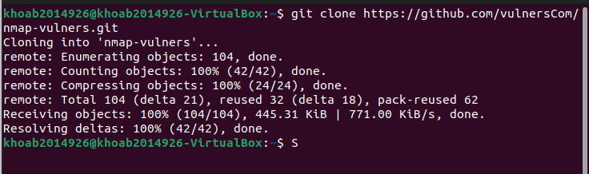

* + Check the network information Target

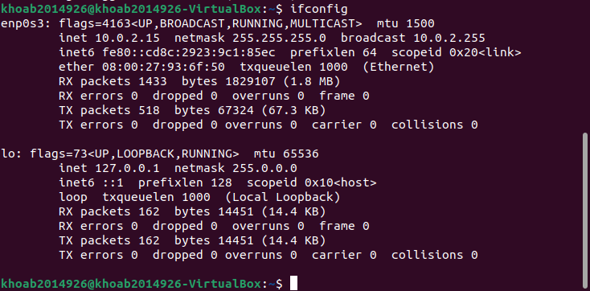

Attacker



* + Running nmap to discover open host in the network
  + 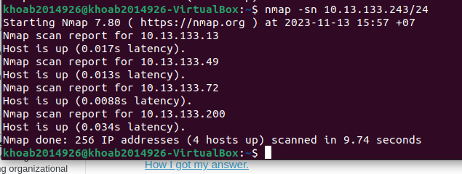
  + See there are a lot of vulnerabilities in the target machince about FTP, SSH, HTTP, IPP

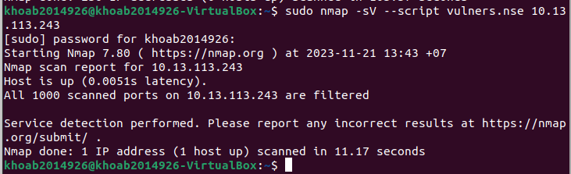

**CVE-2023-41913**

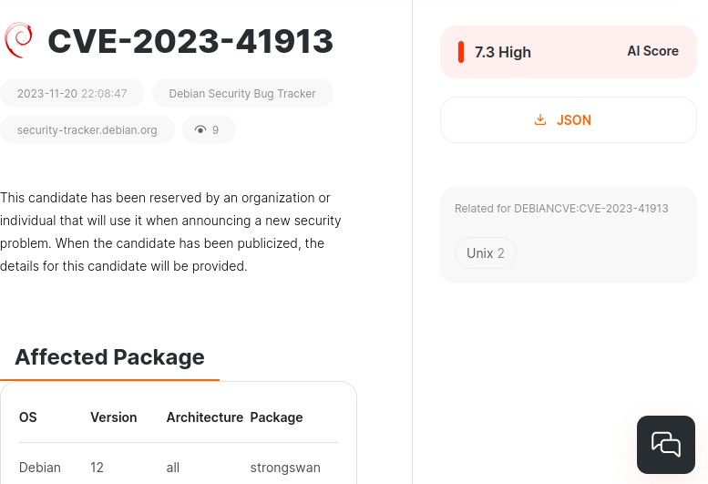

This candidate has been reserved by an organization or individual that will use it when announcing a new security problem. When the candidate has been publicized, the details for this candidate will be provided.

**CVE-2023-6062**

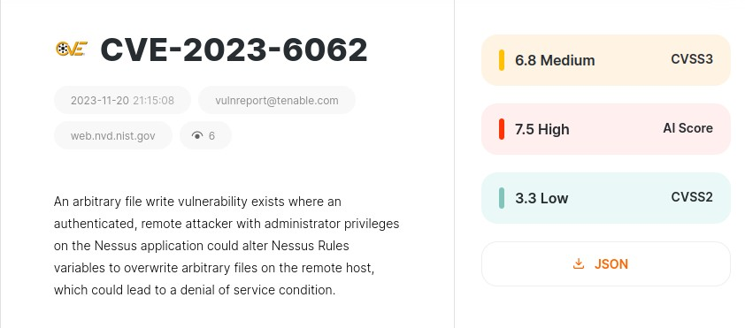

An arbitary file write vulnerability exists where an authenticated, remote attacker with administrator privileges on the Nessus application could alter Nessus Rules variables to overwrite arbitrary files on the remote host which could lead to a denial of service condition.

**CVE-2023-5752**

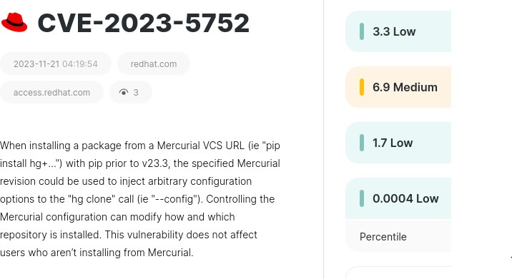

When installing a package from a Mercurial VCS URL (ie “pip install hg+…”)

With pip prior to v23.3, the specified Mercurial revision could be used to inject arbitrary configuration options to the “hg clone” call (ie “—config”).

Controlling the Mercurial configuration can modify how and which repository is installed. This vulnerability does not affect users who aren’t installing from Mecurial>

# LAB15 WEB vulnerability analysis

|  |  |
| --- | --- |
| Student ID |  |
| Name |  |
| Email address |  |
| Class |  |
| Browser |  |

① Select one vulnerability example among SQL injection, XSS, HTTP header injection, programming err message

<https://www.netsparker.com/support/vulnerability-severity-levels-netsparker/>

SQL injection, a prevalent cybersecurity threat, exploits vulnerabilities in web applications to inject malicious SQL code into their database queries. Attackers leverage this technique to manipulate the application's interaction with the database, enabling them to gain unauthorized access to sensitive data, modify or delete crucial information, or disrupt the application's functionality

There are three main kinds of SQL injection attacks:

* In-band SQL injection is the most common type of SQL injection attack. The attacker

uses the same communication channel to launch their attack and to gather their

results. This type of attack is relatively easy to exploit because the attacker can see the results of their attack directly.

* Inferential (blind) SQL injection is more difficult to detect because the attacker does not receive any direct feedback from the database. Instead, the attacker must infer the

results of their attack by observing the application's behavior. This type of attack is

more difficult to exploit because the attacker must be more careful about the SQL code that they inject.

* Out-of-band SQL injection is the most difficult to defend against because the attacker

does not need to communicate directly with the database. Instead, the attacker communicates with a server that they control and the server then communicates with the database. This type of attack is very difficult to detect because the attacker's communication with the database is hidden from the application.

SQL injection attacks pose a serious threat to database security, as they can enable attackers to gain unauthorized access to sensitive data, destroy or modify data, escalate privileges, or even render the database server unavailable. These attacks can have devastating consequences for businesses and organizations, compromising

confidential information and disrupting operations.

② Explain CWE, CVSS or CVE each

CWE (Common Weakness Enumeration) is a list of common software weaknesses that can lead to vulnerabilities. It is a taxonomy of software weaknesses that helps prioritize

remediation efforts and improve software security. Each CWE weakness is assigned a unique identifier and is described in detail, including its causes, consequences, and examples.

CVSS (Common Vulnerability Scoring System) is a standard for assessing the severity of computer security vulnerabilities. It assigns a score to each vulnerability based on three factors: the impact of the vulnerability, the exploitability of the vulnerability, and the scope of the vulnerability. The higher the CVSS score, the more severe the vulnerability. CVE (Common Vulnerabilities and Exposures) is a list of publicly known cybersecurity vulnerabilities. Each vulnerability is assigned a unique identifier and is described in detail, including its name, description, affected products, and mitigation information. The

CVE list is maintained by the National Vulnerability Database (NVD).

③ Search vulnerability level of example from CWE, CVSS or CVE and explain the level

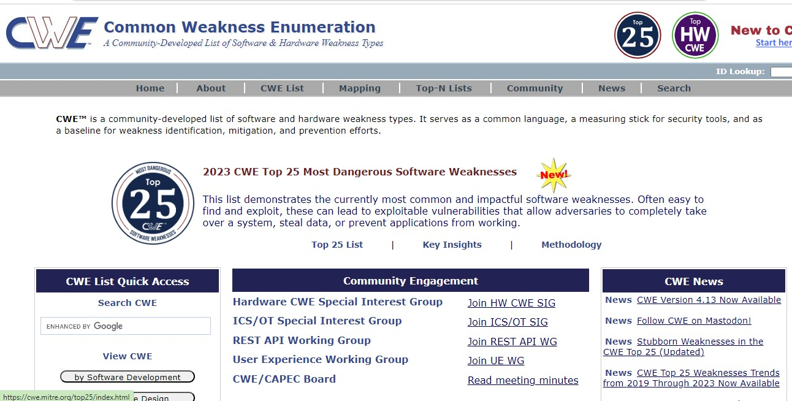

CVE

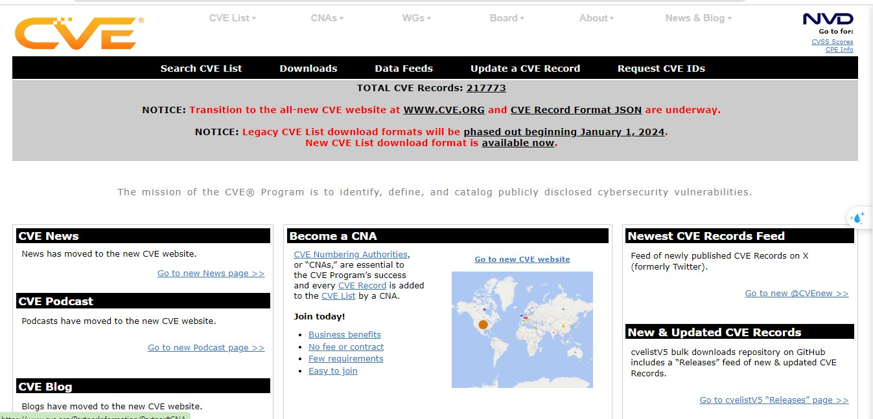

④ Design your own processof preventing or protecting web vulnerability Desgin your own process of preventing or protecting web vulnerability

SQL injection is a common type of web application vulnerability that allows attackers to

inject malicious SQL code into a web page. This code can then be used to steal data, modify data, or even take control of the entire server. There are a number of ways to

prevent SQL injection, including:

* Using prepared statements: Prepared statements are a way of sending SQL queries to the database that prevents malicious code from being injected. The query is first sent

to the database server, which then parses it and prepares it for execution. Any user- supplied data is inserted into the query after it has been parsed, which prevents it from

being interpreted as SQL code.

* Using parameterized queries: Parameterized queries are similar to prepared

statements, but they allow you to specify the data types of the parameters. This can help to prevent SQL injection attacks that exploit type conversion vulnerabilities.

* Escaping user input: Escaping user input is a way of encoding special characters so that they are not interpreted as SQL code. This can be done using a variety of

methods, such as using backslashes to escape single quotes.

* Validating user input: Validating user input is a way of checking to make sure that the

data is in the correct format before it is sent to the database. This can help to prevent SQL injection attacks that rely on invalid data to trigger errors.

* Using a web application firewall (WAF): A WAF is a security appliance that can be used to filter out malicious traffic, including SQL injection attacks. WAFs can be configured to block specific types of SQL injection attacks, or they can be configured to use machine learning to detect and block new types of attacks.

#### References:

<https://portswigger.net/web-security/cross-site-scripting/preventing>

<https://cwe.mitre.org/data/definitions/79.html>

<https://stackoverflow.com/questions/1996122/how-to-prevent-xss-with-html-php>

# LAB #16 encryption & decryption concept

Class M02 Name Trần Đăng Khoa Students ID B2014926

**Check system environment**

|  |  |
| --- | --- |
| **Resource** | **Detail** |
| **Client** | OS: Window Browser: Chrome  Language: Python 3,Java, C |
| **Web Server** | None |

Choose one practice model for exercise

* Exercise model A => Describe encryption & decryption full process and explain

Exercise model A => Describe encryption & decryption full process and explain

- Encryption

+ Plain text: The original, human-readable data that needs protection is known as plain text.

+ Key generation: a key is generated through an algorithm. In symmetric key cryptography, the same key is used for both encryption and decryption, there is a pair of keys: a public key for encryption and a private key for decryption.

+ Encryption Algorithm: The plain text is combined with the encryption key using an encryption algorithm. This process results in ciphertext, an unreadable and seemingly random sequence of characters. + Ciphertext: the result of the encryption process is

ciphertext, which is

the information to be transmitted or stored. It should be computationally infeasible to derive the original plain text from the ciphertext without the proper key.

- Decryption

+ Ciphertext: The encrypted data, or ciphertext, is received by the intended recipient

+ Key Input: In symmetric key cryptography, the same key used for encryption is used for decryption. In asymmetric key cryptography, the recipient uses their private key for decryption.

+ Decryption algorithm: The decryption key is applied to the ciphertext

using a decryption algorithm. This process transforms the ciphertext back into the original plain text.

+ Plain text: the result of the decryption process is the original, readable plain text.

- Example:

+ Encryption Process:

(+) Plain text: Suppose we have the plain text message: “HELLO” (+) Key generation: Generate a secret key, for example, “ KEY123”

(+) Encryption Algorithm: Use a symmetric encryption algorithm to combine the plain text and the secret key. The result might be something like: “VczUq+uM5rXJ8IKFbPvIUw==”

(+) Ciphertext: The final encrypted message, or ciphertext, is “VczUq+uM5rXJ8IKFbPvIUw==”. This is what would be transmitted

of stored.

+ Decryption Process:

(+) Ciphertext: suppose we receive the ciphertext “ VczUq+uM5rXJ8IKFbPvIUw==”.

(+) Key input: Use the same secret key, “KEY123,” for decryption. (+) Decryption Algorithm: Apply the decryption algorithm with the secret key to the ciphertext. The result is the original plain text: “HELLO”.

(+) Plain text: The decrypted message is “ HELLO”, which is the original information.

- Explanation:

+ Security: The security of this process relies on keeping the secret key “KEY123”, confidential. Without the key, it should be computationally to derive the original plain text from the ciphertext.

+ Use case: This example represents a simplified scenario. In real- world applications, more robust encryption algorithm and key management would be employed.

* Exercise model B => Describe Secret Key Cryptography and public key - Secret Key cryptography: also known as Symmetric Cryptography, operates on the principle of using a single shared secret key for both encryption and decryption. In this model, the communicating parties must

agree upon and securely distribute the secret key before initiating secure communication. The sender employs this secret key to transform

plaintext into ciphertext, and the recipient uses the same key to decrypt and retrieve the original message. Example of secret key cryptography algorithms include DES(data encryption Standard) and AES(Advanced

encryption standard). While this approach is efficient for large-scale data

encryption, the challenge lies in securely distributing the secret key among all involved parties.

- Public Key: In contrast, public key cryptography, or asymmetric key cryptography, introduces a pair of mathematically related keys for secure communication: a public key and a private key. Each user possesses their unique pair of keys. The public key can be openly shared, allowing anyone to encrypt messages or verify digital signatures, while the corresponding private key is kept confidential. This model eliminates the need for secure key distribution, making it particularly advantageous.

Public key cryptography is commonly used for secure key exchanges and digital

signatures. Examples of algorithms in this category include RSA(Rivest Shamir-Adleman) and ECC(Elliptic curve Cryptography). Despite being

generally slower for large-scale data encryption, public key cryptography plays a crucial role in ensuring secure communication over insecure channels. In practice, a combination of both symmetric and asymmetric cryptography is often employed to address various security requirements.

# LAB 17 encryption & decryption

Class: M02 Name: Trần Đăng Khoa Students ID: B2014926

**Check system environment**

|  |  |
| --- | --- |
| Resource | Details |
| Client | OS  Browser : Type and version : Google Chrome Version 77.0.3865.90 (Official Build) (64-bit)  Language : Type and version : HTML5, CSS, Javascript |
| Web Server | OS  Web Server : Type and version  Web Application : Type of Web Application  Language : Type and verion |
| DB Server | DB : Type and version  File Type :: |
| HW device | Personal PC |

Choose one practice Model among4

#### [Model3] ccode encryption process and explain

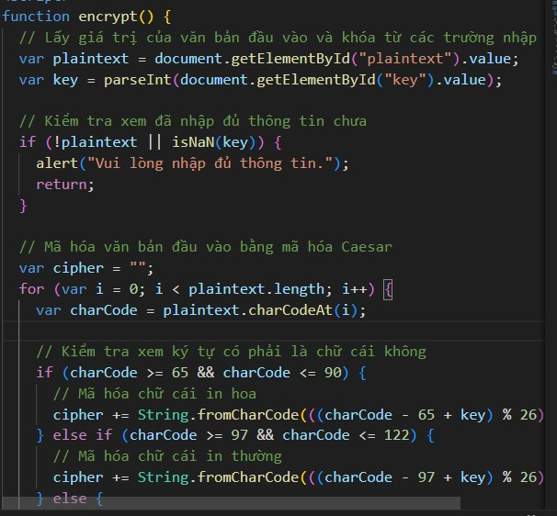

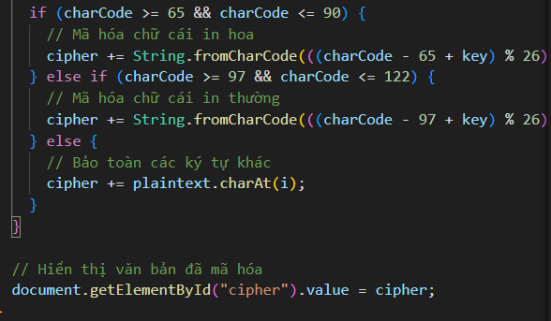

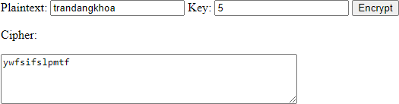

Explain:

## LAB18 TCPing

|  |  |
| --- | --- |
| Name | Tran Dang Khoa |
| Email address | [Khoab2014926@student.ctu.edu.vn](mailto:Khoab2014926@student.ctu.edu.vn) |
| Class | M02 |
| Browser | Safari, Chrome, IE, Firefox |

|  |  |  |
| --- | --- | --- |
|  | attacker | target |
| OS | Windows | Ubuntu |
| IP |  |  |
| Attacking tool | **TCPing** |  |
| Monitoring  tool |  | Gnome  Wireshark |
| Blocking tool |  | Linux iptables |
| Process | TCPing to target  Install wireshark on target Install gnome on target  Analyze packet on target using wireshark Monitor network traffic on target using gnome Block attacking IP on target using iptables  Confirm blocking result using wireshark on target | |

① Install TCPing on windows

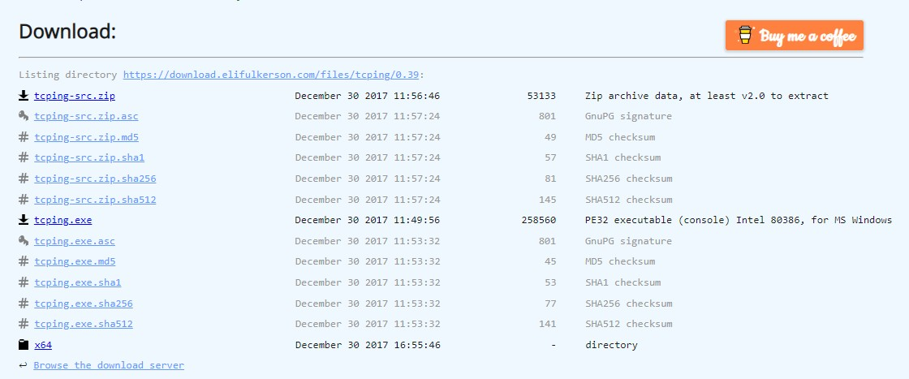

② Move TCPing file to windows => system32

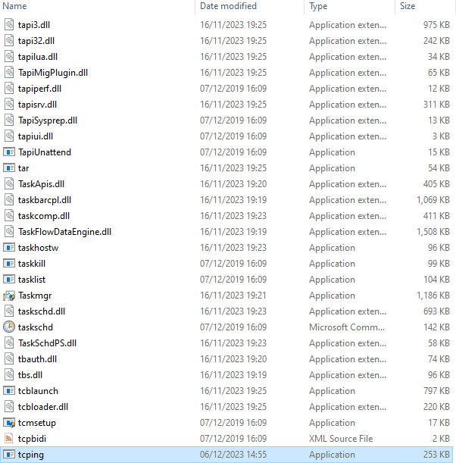

③ CMD => TCPing to target

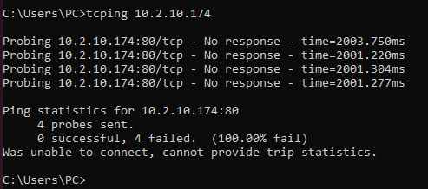

④ Install wireshark on ubuntu/ target

apt-get install wireshark

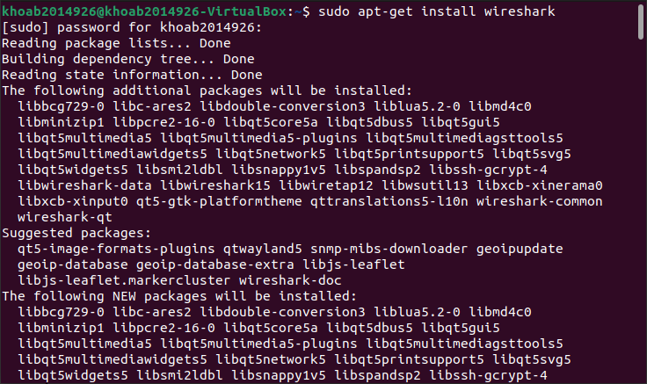

⑤ Analze packet situation on target using wireshark

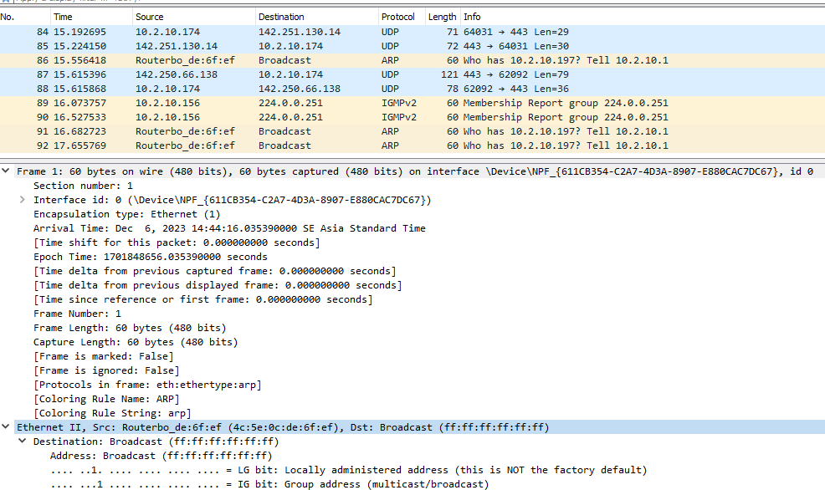

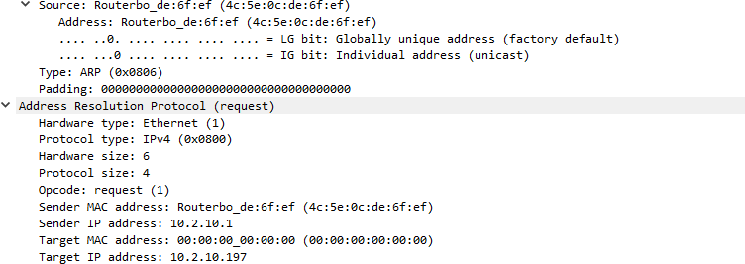

⑥ Install gnome on target

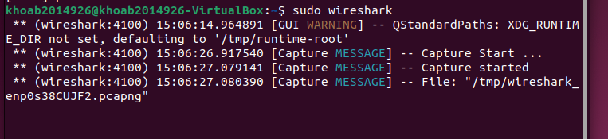

⑦ Check the traffic volume of target system using relevant tool

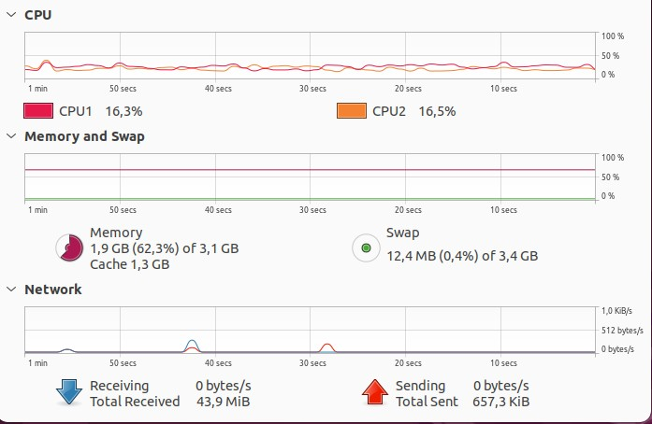

⑧ Protect/block the attack from target system

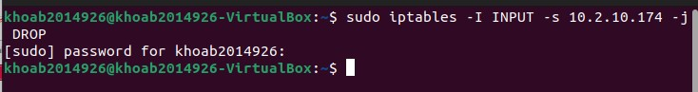

⑨ Confirm the Protect/blocking methods on laptop side using relevant tool

